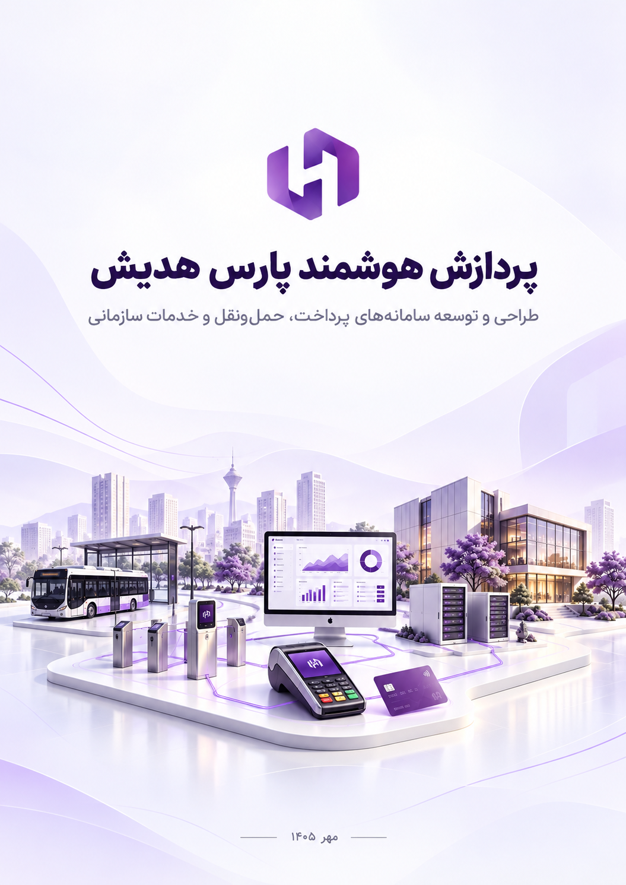

Contents
Company profile 4
Technical capabilities 5
Areas of activity 5
Customers and partners 6
Our products and services: 7
Payment switch 7
Product features and capabilities 7
Users 8
Images: 8
Settlement switch 9
Product features and capabilities 9
Users and applications: 10
Images 10
Credit payments and account credit management 12
Product features and capabilities: 12
Users and applications 13
Images: 13
Electronic wallet 15
Product features and capabilities 15
Users and applications 16
Images 16
Fleet management and driver assistant 18
Product features and capabilities 18
Users and applications 19
Images: 19
University transport payment concept 22
Planned features and capabilities 22
Users and applications 23
Images: 23
Payment and validation equipment 25
Main features 25
Users and applications 25
Device images: 25
Smart parking 26
Product features and capabilities 27
Users and applications 27
Usage steps 27
Images: 28
Mobile monitoring and observation recording concept 29
Product features and capabilities 30
Users and applications 30
Hadish Ticket 31
Product features and capabilities 31
Users and applications 32
Usage steps 32
Images: 33
Hadish Market 34
Product features and capabilities 35
Users and applications 35
Images: 36
Customer support chatbot and intelligent assistant 38
Product features and capabilities 39
Users and applications 40
Images: 40
Intelligent polyclinic appointment and queue management system 41
Product features and capabilities 41
Users and applications 42
Images: 42
Intelligent physician and clinic assistant 44
Product features and capabilities 44
Users and applications 45
Images: 46

Company profile

Pardazesh Hooshmand Pars Hadish designs and develops software systems and connected equipment. The company's solutions cover payments, transportation, commerce, and enterprise services, with a focus on users' needs and each organization's operational processes.
This profile presents fourteen Pars Hadish solutions and product concepts, together with the company's areas of expertise, customers, and partners. Each section explains the solution's purpose, principal users, and how it is used.

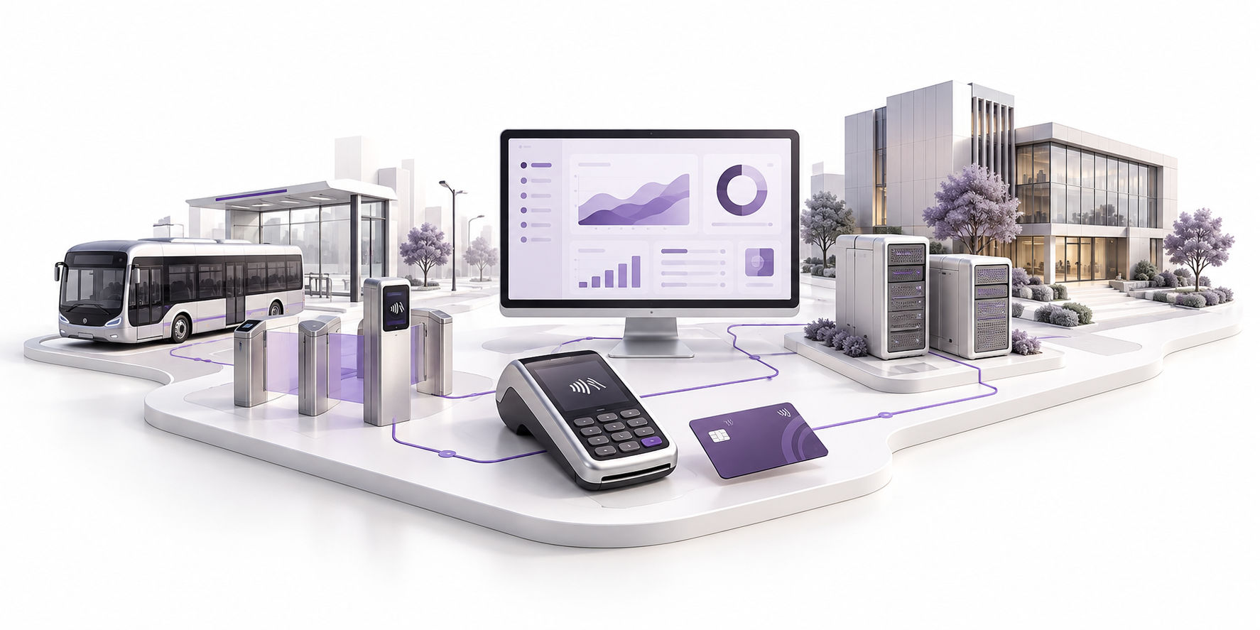

Technical capabilities
Pars Hadish's technical capabilities include developing management panels and user interfaces, designing operational processes, and developing embedded software for equipment. For systems that communicate with other devices or services, the design also addresses the status of each request and how to handle lost connections or inconclusive responses.
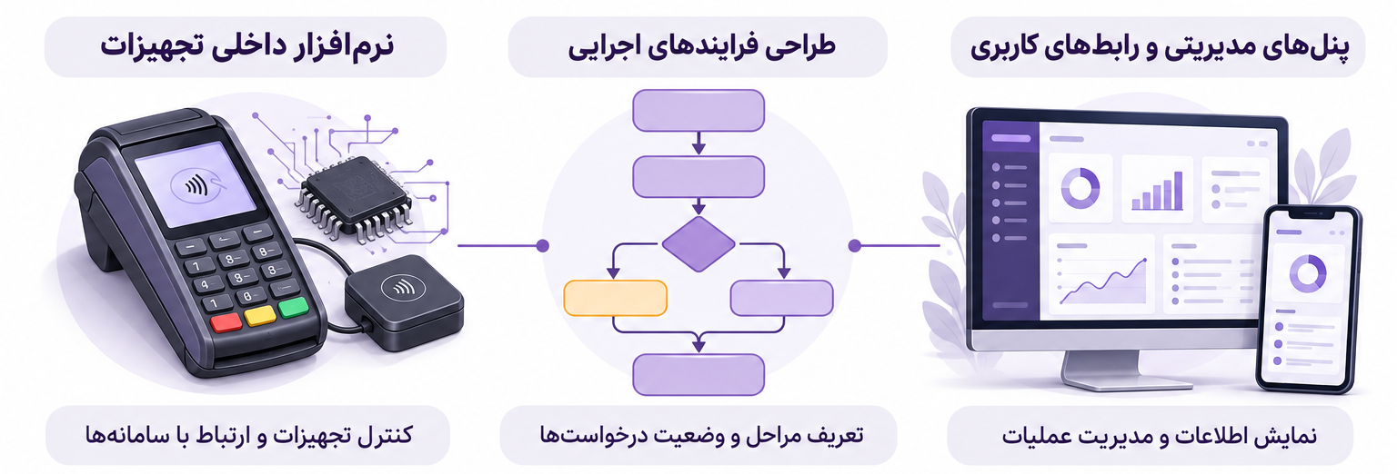

Areas of activity
- Payments and settlement
- Credit and wallet management
- Transportation and validation equipment
- Parking management systems
- Ticket sales and access control systems
- Online retail
- Chatbots and intelligent support assistants
- Mobile monitoring concepts
- Polyclinic management
- AI-powered physician and clinic assistants
- Support operations and assignment management

Customers and partners
Pars Hadish has worked with organizations in payments, commerce, education, and municipal services. The names and logos of the company's featured customers and partners appear below.
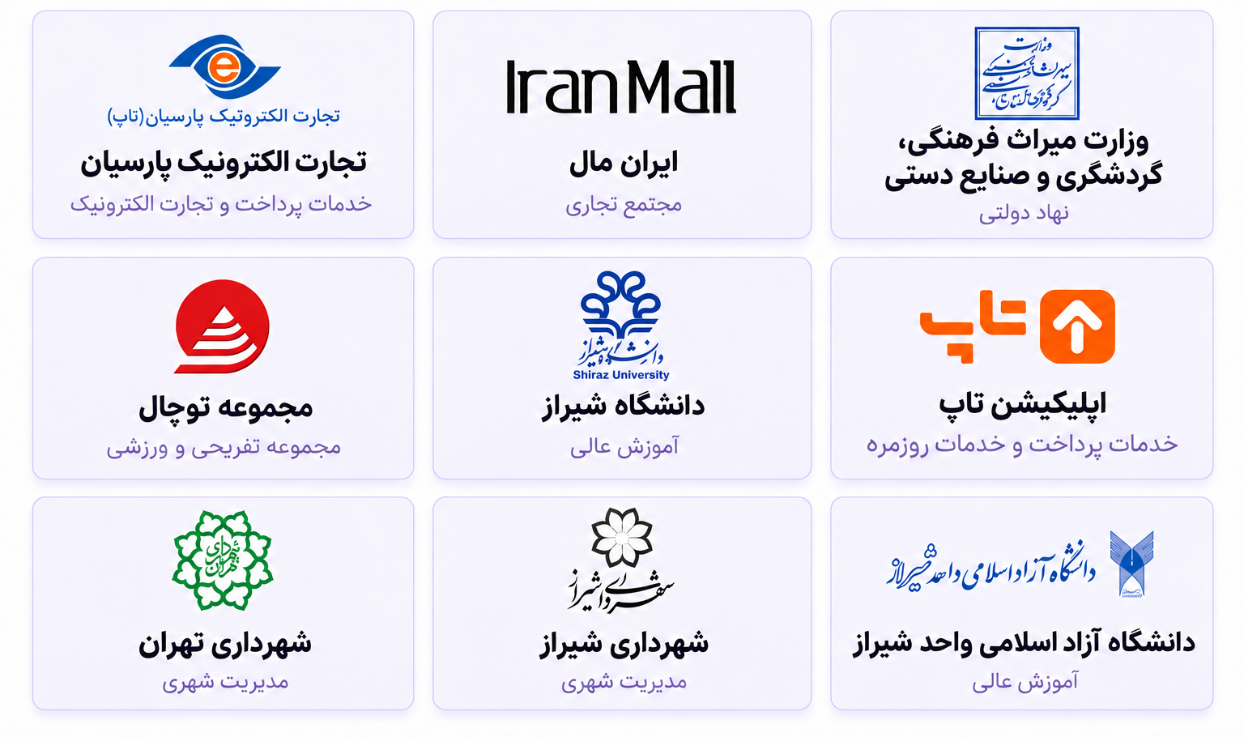

Our products and services:

Payment switch
The Pars Hadish payment switch receives, routes, and processes payment requests and connects terminals, gateways, and financial services.
When a user submits a payment request through a terminal or gateway, the switch routes it to the responsible processing service based on the transaction information and defined rules, then returns the response to its origin. For payments using internal accounts, rules such as the eligible account, available balance, and merchant restrictions govern this process. Connections to banks and payment companies use the interfaces and infrastructure required for each project.
For example, in an organization's payment network, a user can use a cash or credit account at authorized merchants. The system checks and processes the purchase request according to the accounts and payment rules, then returns the result to the terminal or gateway.
The management panel also allows staff to search and review transactions. Details such as the time, amount, terminal, reference number, tracking code, and recorded response can be reviewed to answer customer inquiries and follow up on operations.
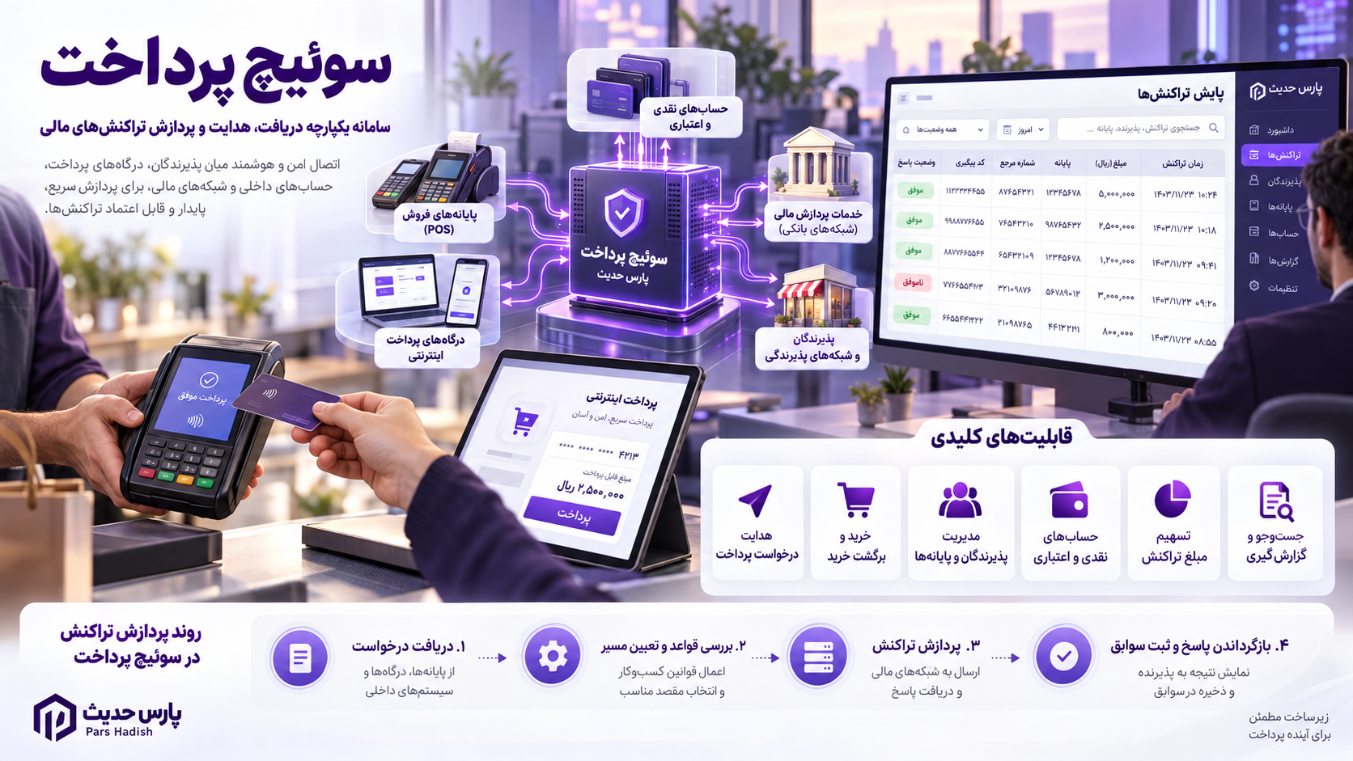

Product features and capabilities
- Receive and route payment requests from connected terminals and gateways.
- Support purchase, purchase confirmation, purchase reversal, and balance inquiry processes.
- Define and manage merchants and their terminals.
- Define rules for using cash and credit accounts and the order in which funds are debited from them.
- Define restrictions on credit use within the authorized merchant network.
- Define how a payment amount is split among multiple merchants.
- Search, filter, and export transaction reports according to the user's access permissions.

Users

Images:
Transaction report:
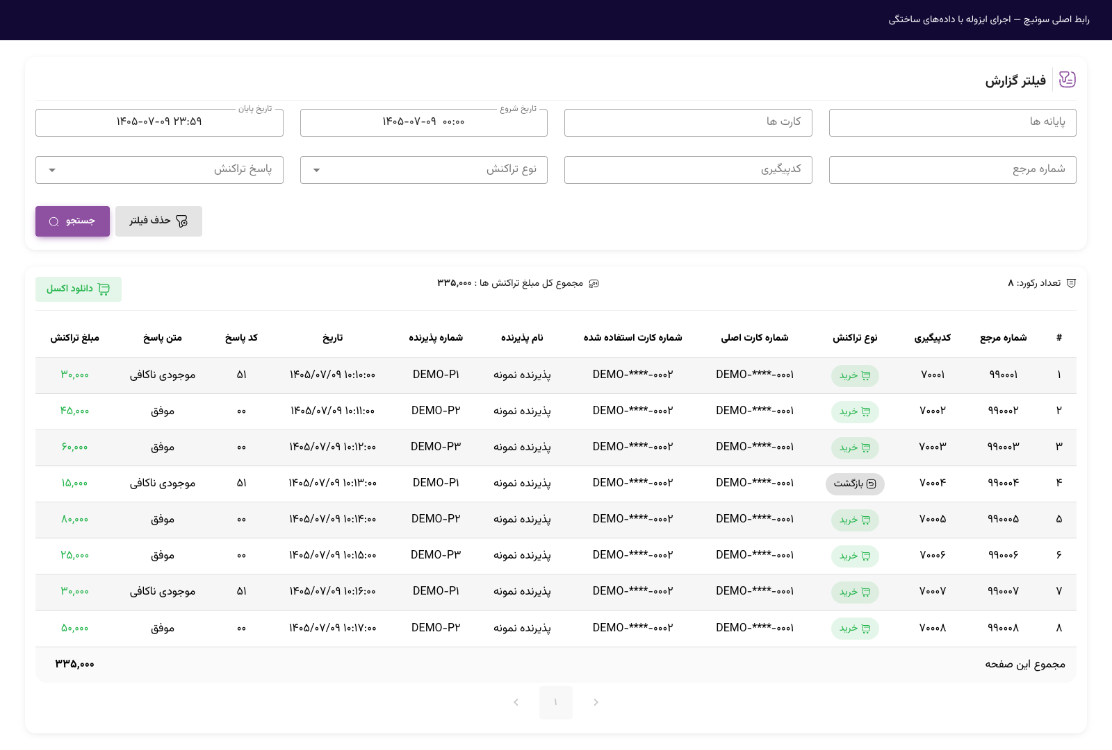

Settlement switch

The Pars Hadish settlement switch manages transaction settlement with merchants, from reviewing transactions eligible for settlement to preparing and submitting fund transfer requests to the relevant service.
The system receives transactions from the payment switch, performs the required checks, and reviews their settlement conditions and timing. It then creates fund transfer records for eligible transactions and submits them to the relevant banking or credit service through the configured connections.
For example, an organization can settle with its merchants on a daily schedule. The system identifies eligible transactions and prepares fund transfer information based on the destination account and settlement rules. Staff can also use the panel to track settlement statuses and cases that require review.
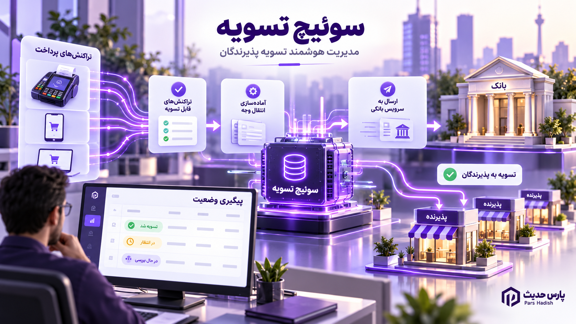

Product features and capabilities
- Receive transactions requiring settlement from the payment switch.
- Record merchants' destination account details, such as the account holder's name and IBAN.
- Define settlement conditions and schedules, including daily, weekly, and monthly cycles.
- Support cash and credit settlement scenarios according to the connected services.
- Check restrictions and blacklists before proceeding.
- Check transaction and settlement totals to identify discrepancies.
- Create fund transfer records and submit them to the relevant service.
- Display account and transaction settlement statuses in the management panel.

Users and applications:

Images
Settlement profile, card reference, and identifier range settings:
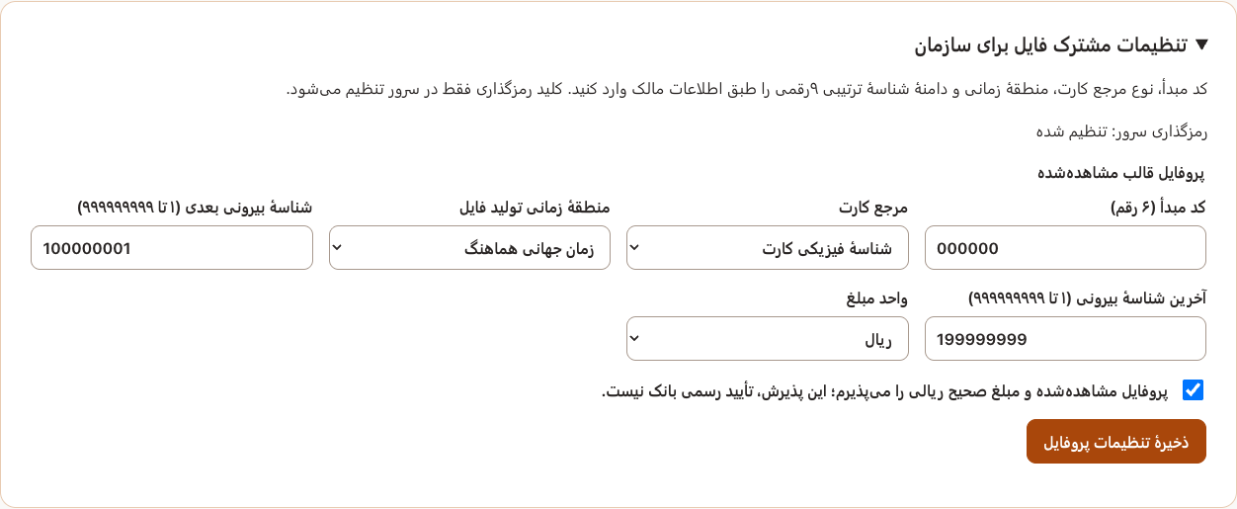
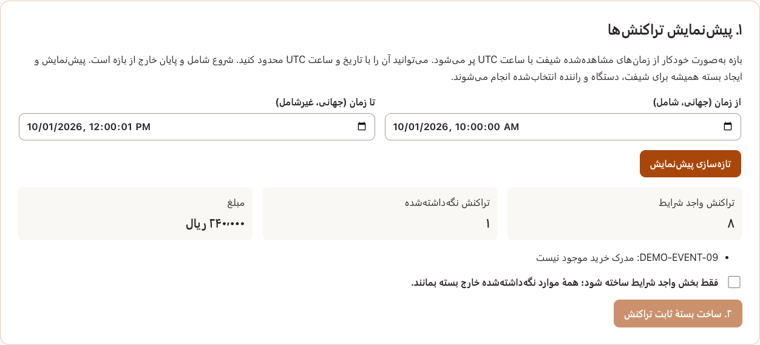

Settlement batch details
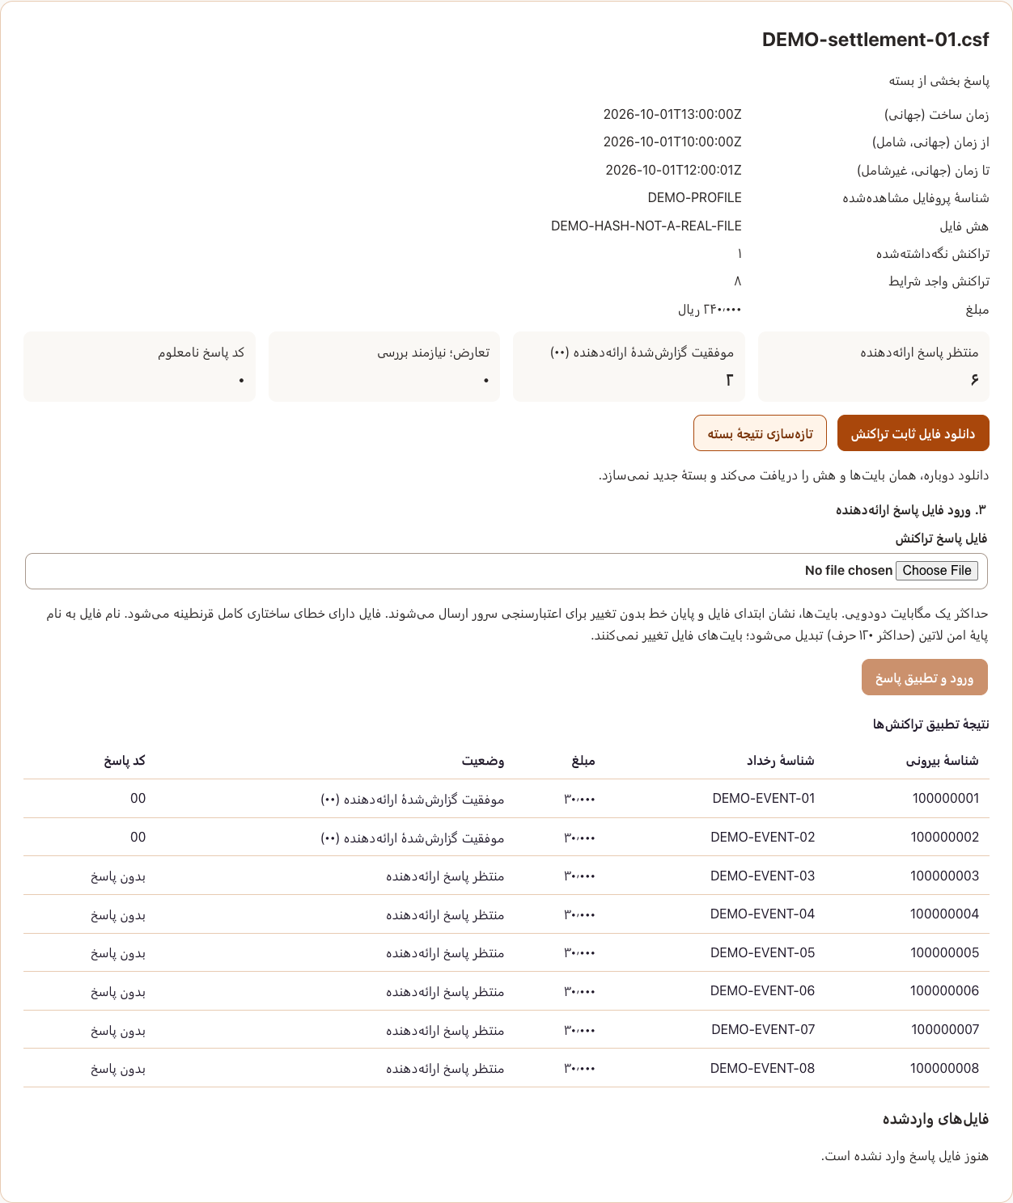

Credit payments and account credit management

The Pars Hadish credit payment management system manages customers' credit applications, credit allocation, and repayment tracking according to defined plans.
Credit plans are defined in the system with specified amounts, terms, and conditions. An agent records the customer's information and selected plan, and the responsible staff review the required information and documents. Once the process is complete and the necessary approvals have been received, credit is allocated to the customer and the plan is activated.
For example, a customer may apply for a credit plan with installment repayments. The agent records the customer's information, and guarantee documents and installment checks are submitted for review if the plan requires them. After the documents have been approved and credit allocated, the plan's status, due dates, and repayment history can be tracked through the panel.
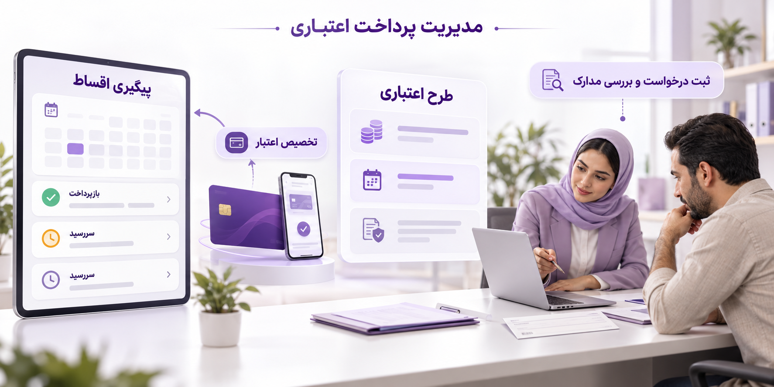

Product features and capabilities:
- Credit plan definition: Set the amount, term, and conditions of each plan.
- Customer registration and management: Maintain customer information and the plans registered for each customer.
- Credit application review: Approve or reject the selected plan and record the review outcome.
- Guarantee registration and review: Receive information and images of guarantee documents according to the plan's conditions.
- Installment management: Record and view installments and due dates associated with a plan.
- Cash and check repayment support: Record payment receipts or check information and track their review.
- Credit allocation and credit card issuance: Complete the relevant steps after the necessary approvals have been received.
- Application status tracking: View application stages, approved documents, rejected items, and information requiring correction.
- Role and access management: Separate the responsibilities of agents, managers, and operators in the credit review and allocation process.

Users and applications

Images:
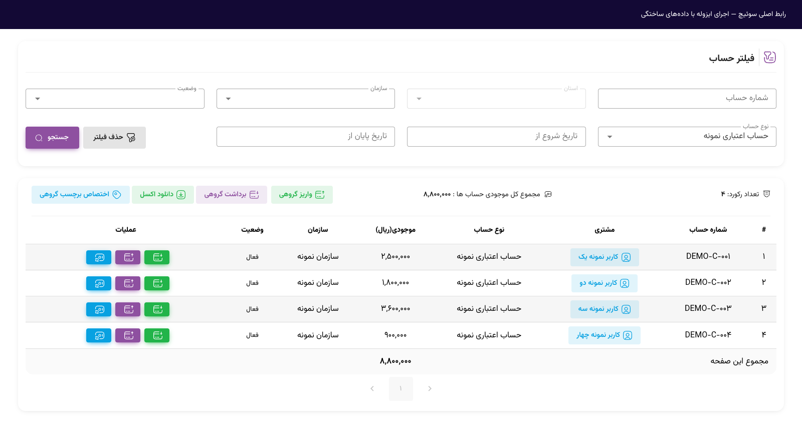
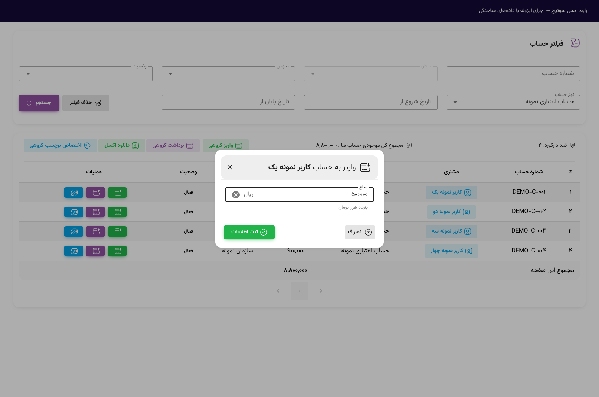
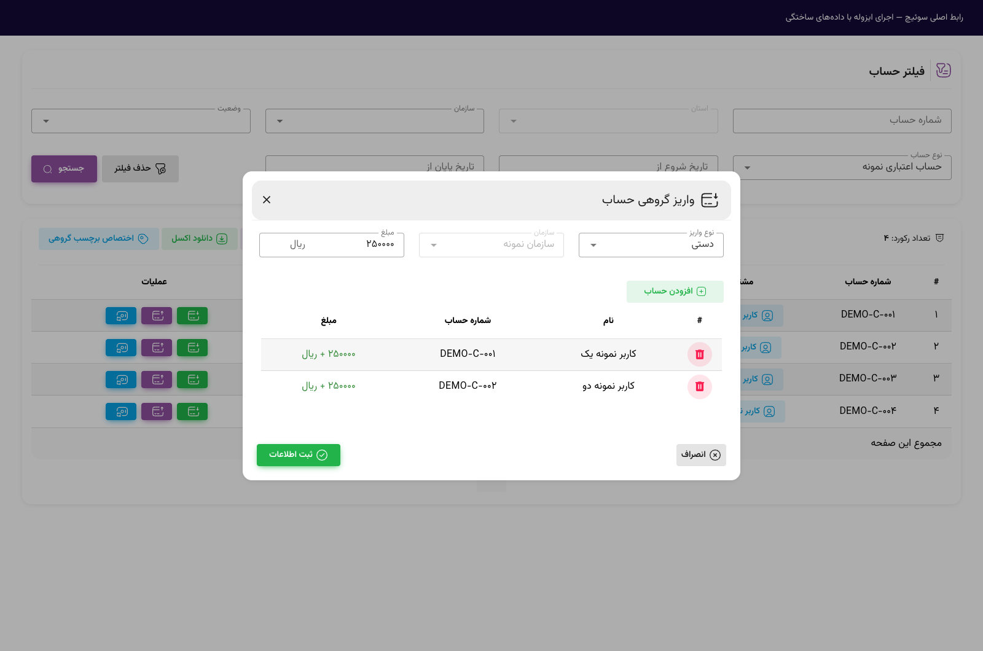

Electronic wallet

The Pars Hadish electronic wallet manages users' account balances, records deposits and withdrawals, and tracks their history.
This solution helps organizations review and manage users' wallet balances in a management panel. Authorized staff can find an account, view its balance, and record a deposit or withdrawal. Operations are also visible in the account statement so that changes in the balance can be tracked.
For example, recording a deposit increases the wallet balance, while recording a withdrawal reduces it. Finance staff can review the account statement to identify which operation caused each change in balance. Funding methods and conditions of use are determined according to each organization's needs.


Product features and capabilities
- Wallet list: View the account number, associated organization, account type, active status, and balance.
- Account search and filtering: Find an account using the details and filters available in the panel.
- Wallet deposits: Record a deposit amount to increase the selected account's balance.
- Wallet withdrawals: Record a withdrawal amount and review its effect on the account balance.
- Account balance: Check the balance and compare it before and after an operation.
- Account statement: Review deposit and withdrawal records to track changes in the balance.
- User access control: Separate permission to view information from authorization to perform financial operations.

Users and applications

Images
Wallet account report:
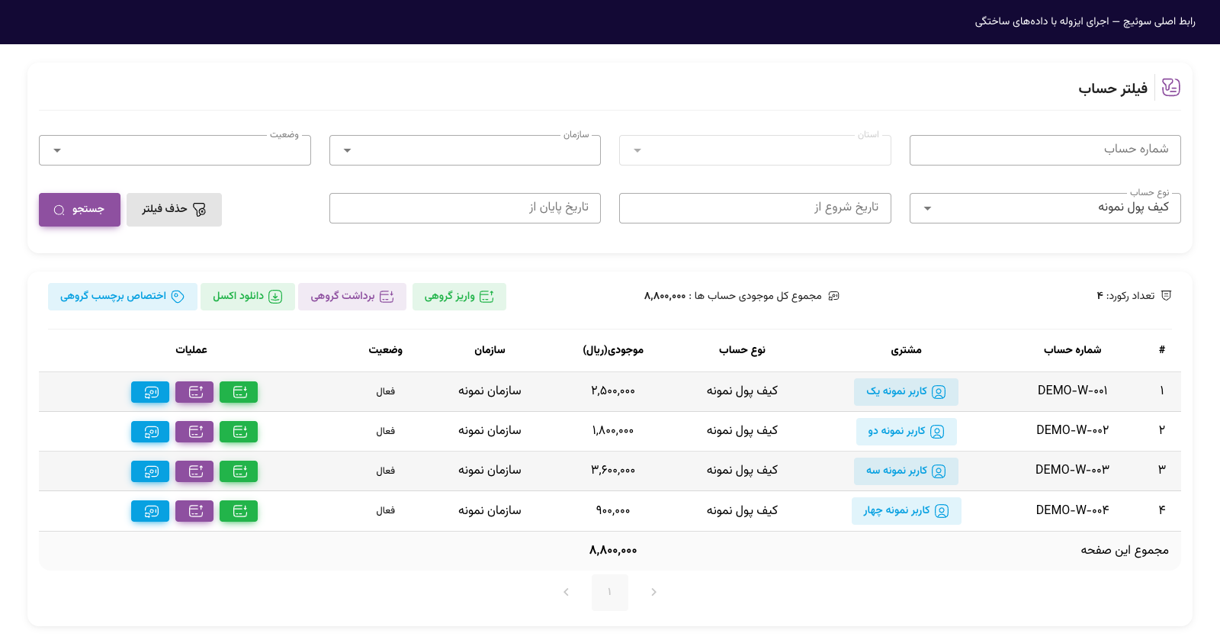

Account withdrawal form:
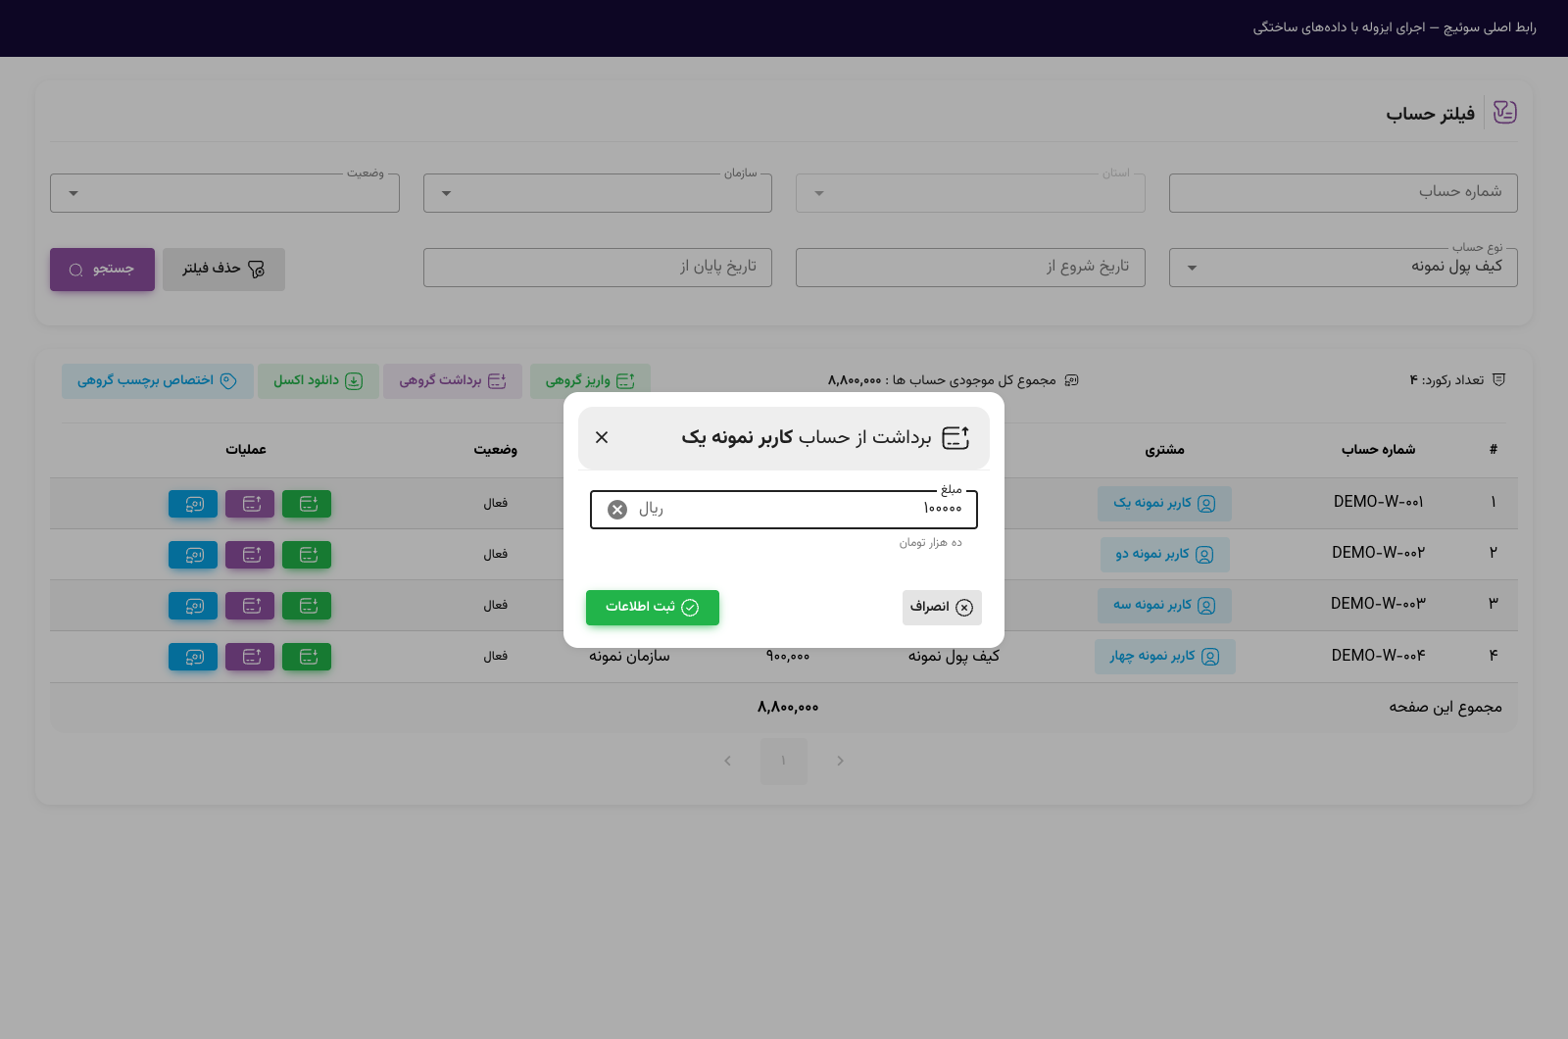
Account statement report:
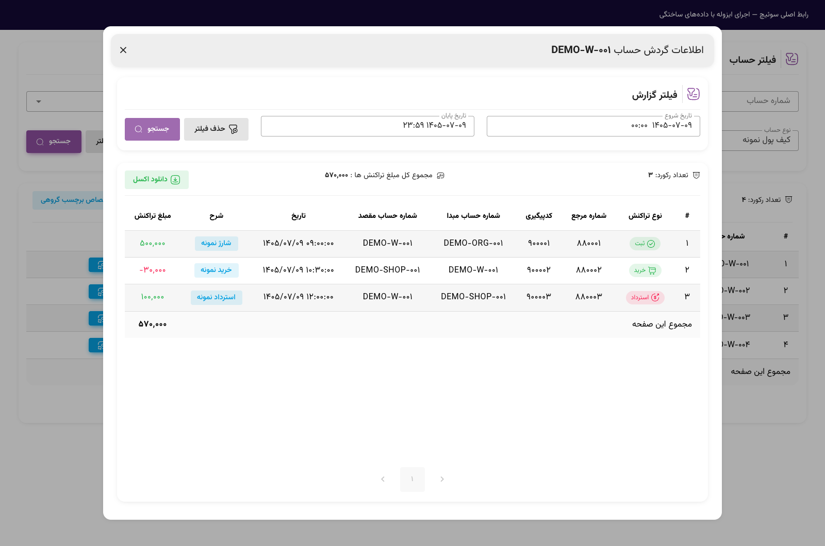

Fleet management and driver assistant

The Pars Hadish fleet management and intelligent driver assistant solution is designed to coordinate drivers' activities, monitor bus movements, manage fare payments, and review fleet performance.
The solution connects an onboard bus device to the central fleet management system. Drivers use the device to sign in and start their shifts. Movement data, bus locations, and fare transactions are linked to the relevant driver, vehicle, and route so that each shift's activity can be reviewed.
For example, control center staff can view the locations of buses on a route on the map, compare their movements with the schedule, and investigate delays or unusual stops. Drivers receive route information, work schedules, and relevant notifications on the onboard device. The recorded data provides the basis for performance reports, revenue reviews, and subsidy calculations.
Under this concept, bus locations and estimated arrival times are made available to partner systems and applications through a web service so that passengers can also check service status.


Product features and capabilities
- Driver and shift management: Register drivers, assign vehicles, and record shift start and end times.
- Fleet tracking: Display bus locations and movement history on the map.
- Service scheduling: Set service schedules and intervals between buses.
- Driver assistant: Display route information, work schedules, and notifications on the onboard device.
- Fare and payment management: Set fares and connect to fare cards, wallets, and payment services.
- Performance monitoring and alerts: Review distance traveled, delays, unauthorized stops, and route deviations.
- Subsidy management: Calculate subsidies and deductions based on fleet rules and performance.
- Management reporting: Provide operational and financial reports by driver, vehicle, and route.
- Passenger information: Provide route information and estimated arrival times through partner systems.
- Integration and access: Connect to enterprise systems and define user permissions.

Users and applications

Images:
Route and fare management:
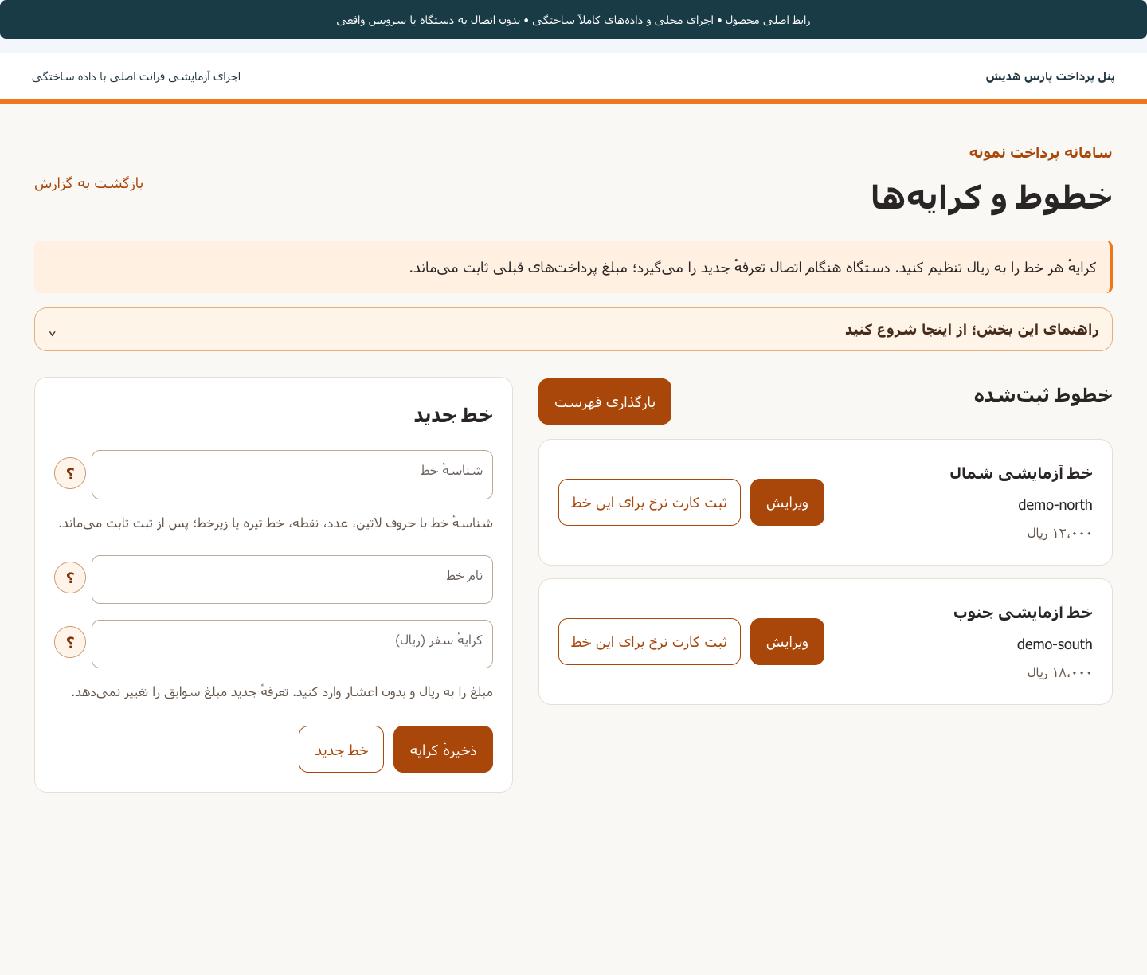
Driver list and registration form:
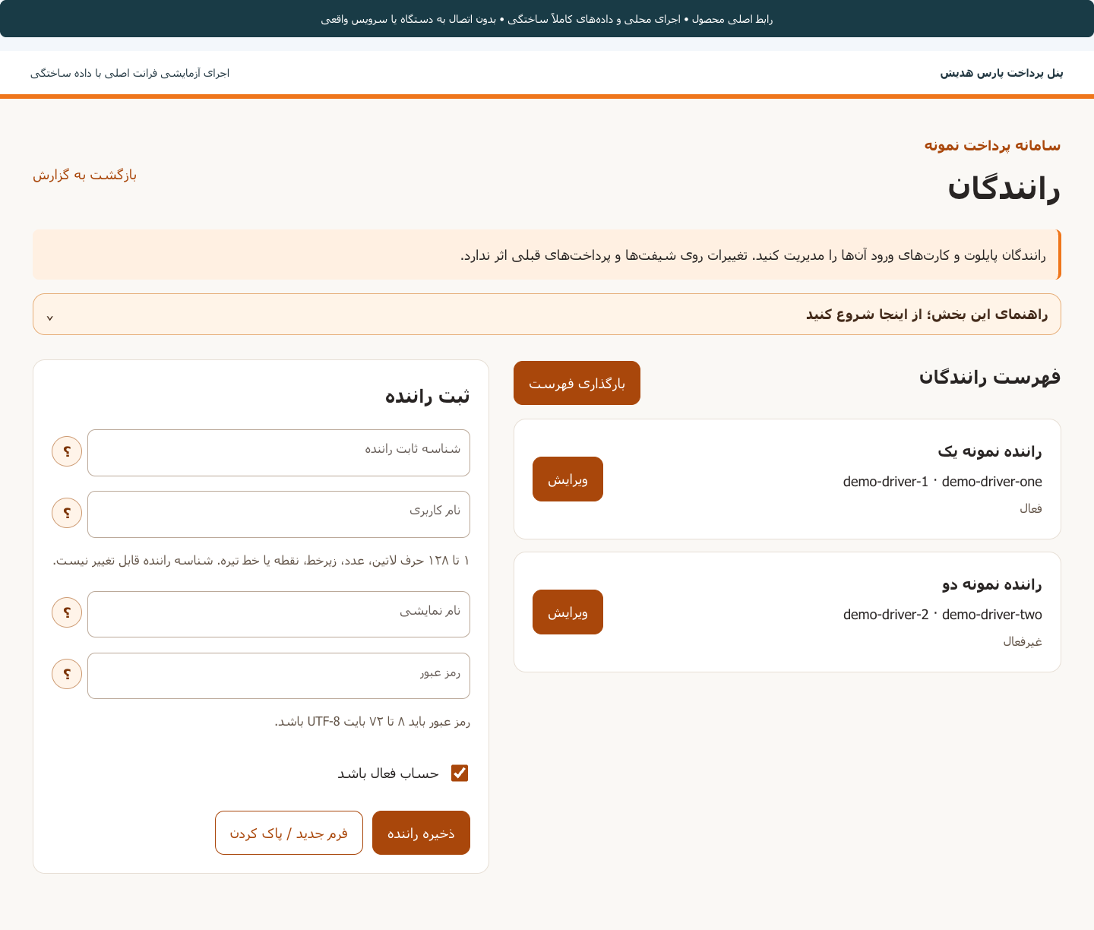
Payment terminal management and route assignment:
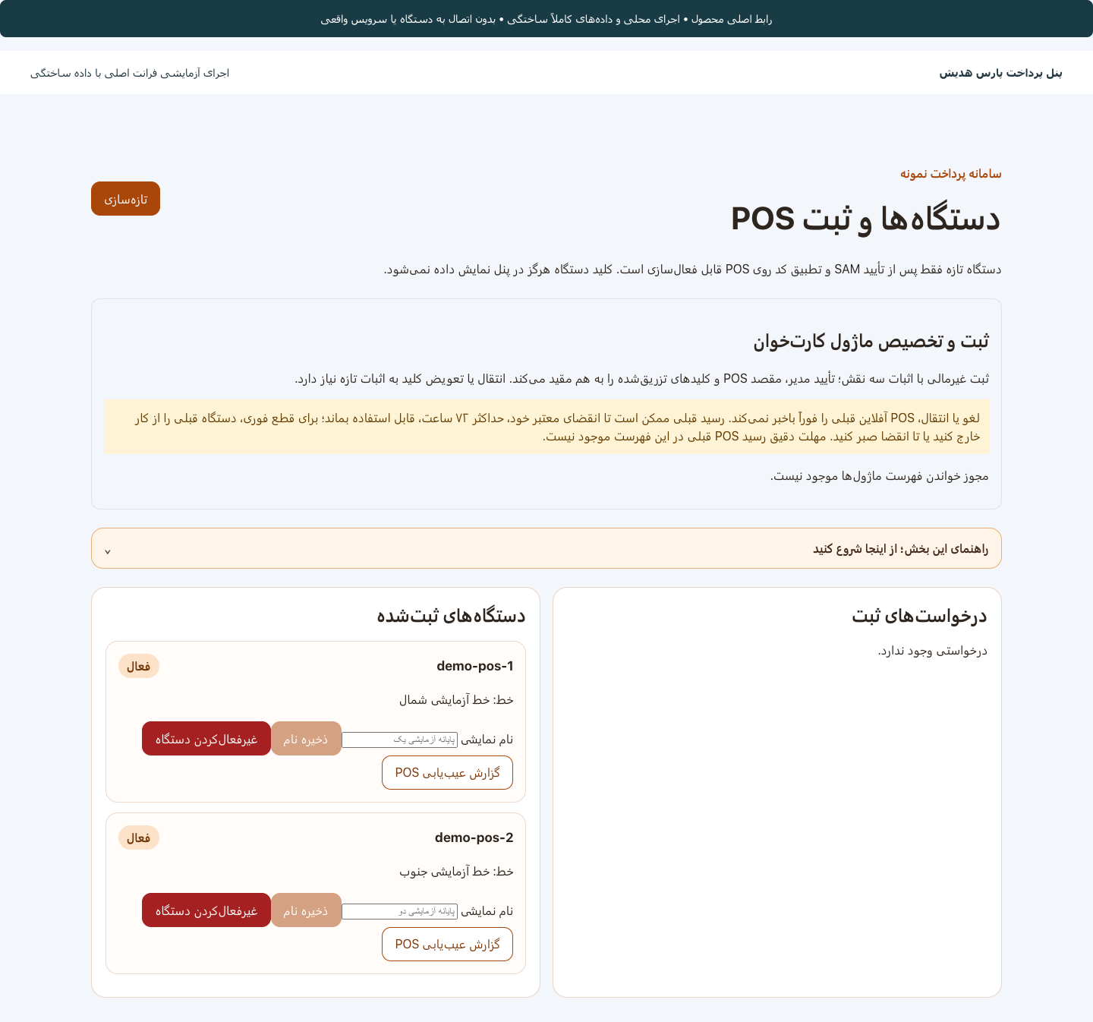

University transport payment concept

The Pars Hadish university transport payment concept provides a way to collect and track university shuttle fares by route and work shift.
Under this concept, each payment request is linked to its route and shift, and its result is displayed as approved, declined, or unresolved. This distinction helps drivers and support staff identify the payment status and review cases that require follow-up.
For example, if no conclusive response is received during fare payment, the transaction remains unresolved, and the next request is blocked until its result is established. An uncertain payment result is therefore treated separately from a declined payment.


Planned features and capabilities
- Payment association with route and shift: Identify the route and shift associated with each request.
- Fare payment request: Start the fare collection process during the active shift.
- Payment status display: Distinguish approved, declined, and unresolved results.
- Subsequent request control: Block a new request until the outcome of the unresolved payment has been established.
- Unresolved payment tracking: Check the result through the connected inquiry service.

Users and applications

Images:
Report in the university transport support panel | Transaction report:
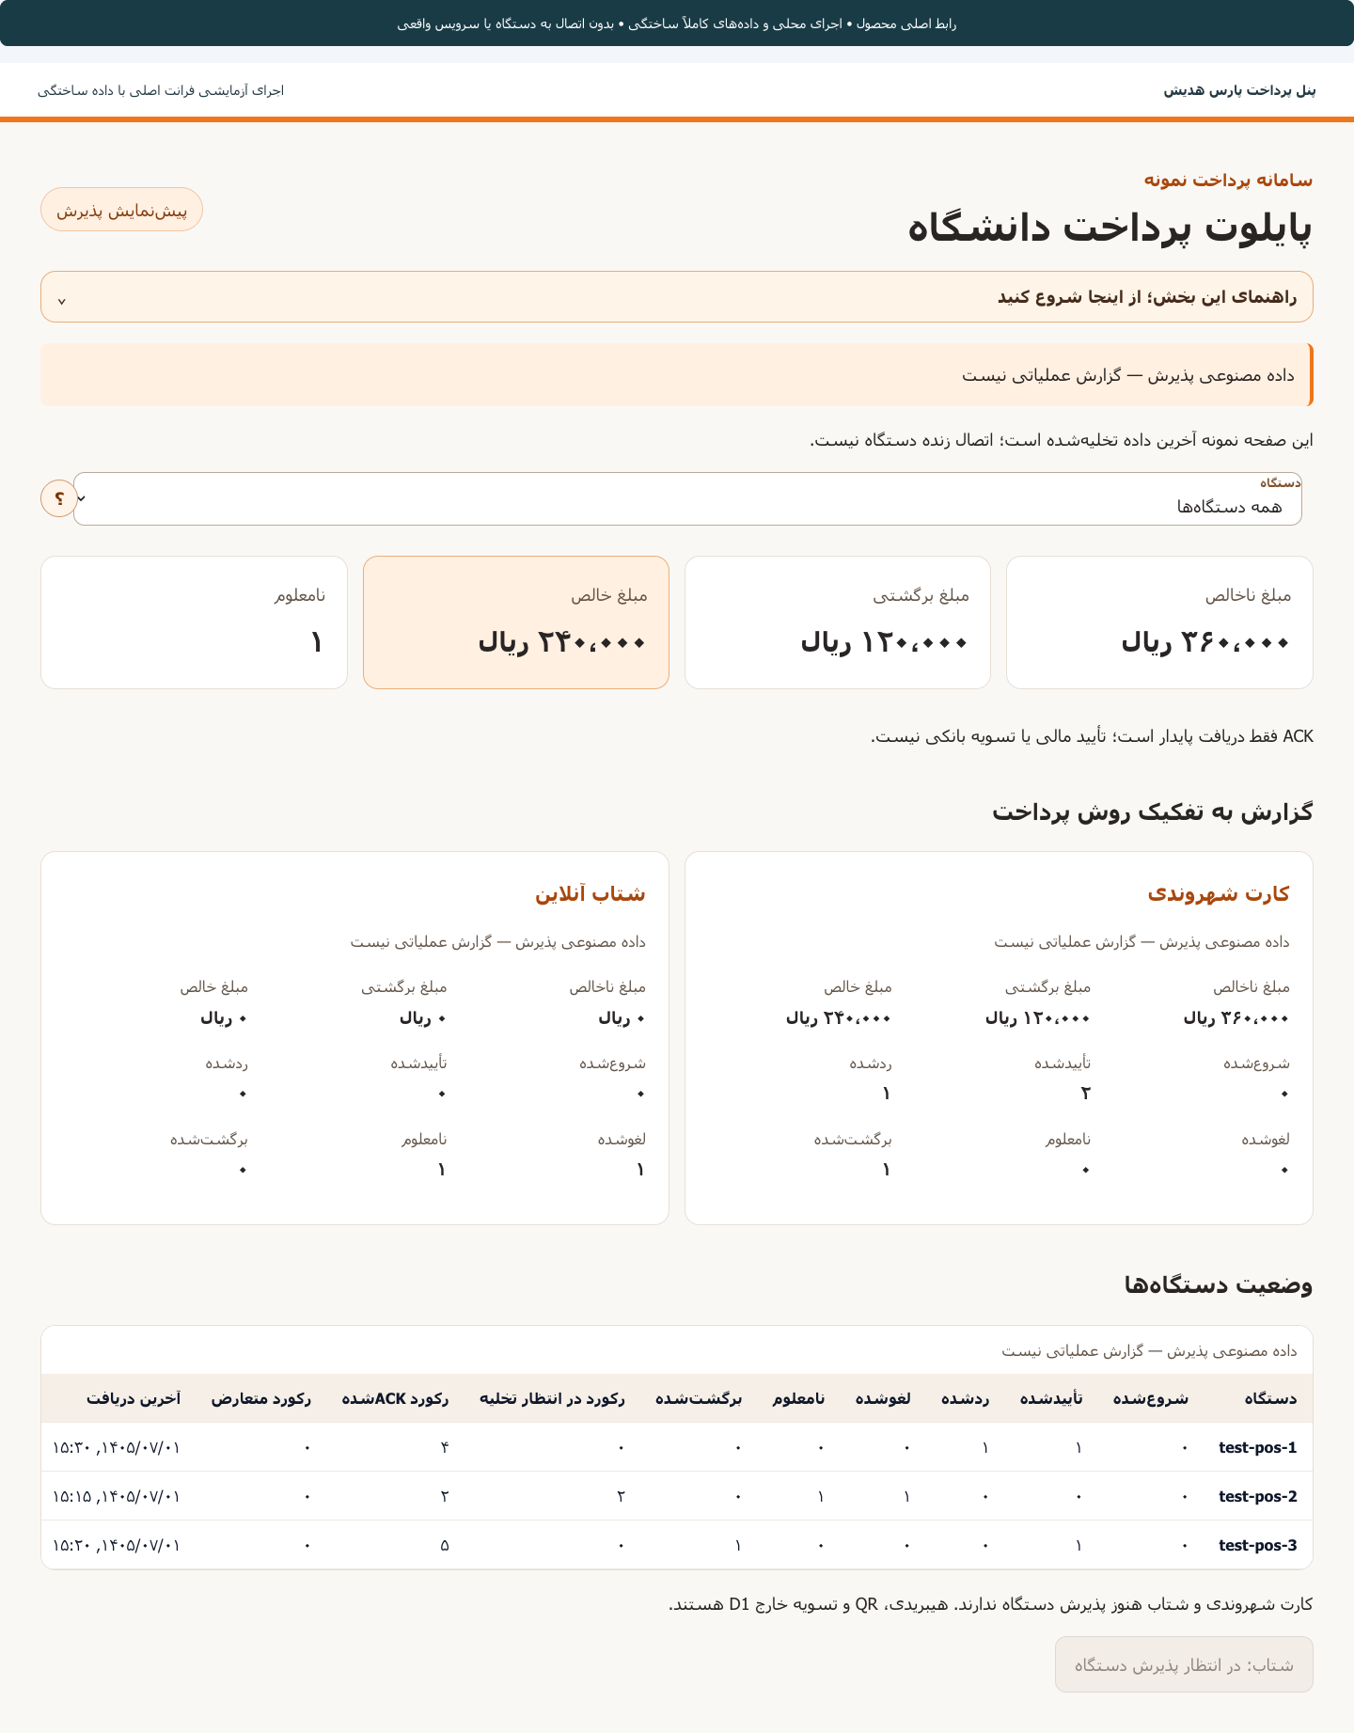 | 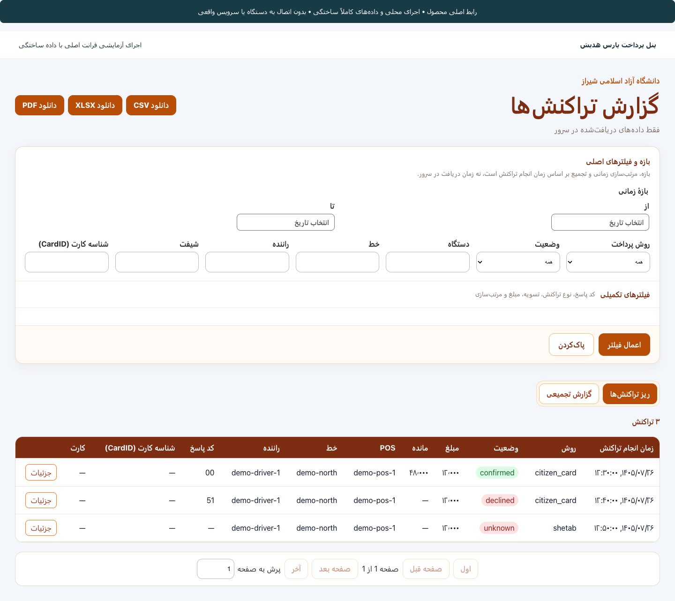

Route and fare selection card management:
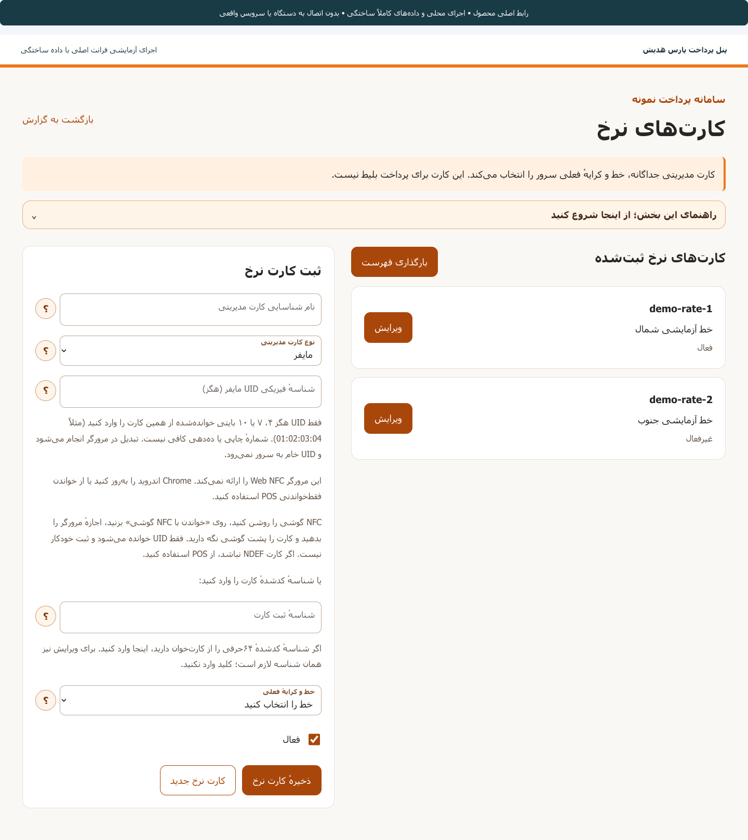

Payment and validation equipment

Pars Hadish payment and validation devices collect fares and validate passenger cards in transport fleets. Passengers present a card to request payment; the device contacts the central system, receives and displays the result. Pars Hadish designs and develops the embedded software, electronic boards and hardware as an integrated whole.

Main features
- Card fare payment: Read passenger card information to make a payment.
- Payment result display: Inform the passenger and driver of the transaction status.
- Dedicated device software: Run the payment process according to the project's requirements.
- Board and hardware design: Develop the device's electronic and physical components.
- Central system connection: Exchange information to validate cards and process payments.
- Fleet management coordination: Link payment information to the route, vehicle and driver's shift.

Users and applications

Device images:
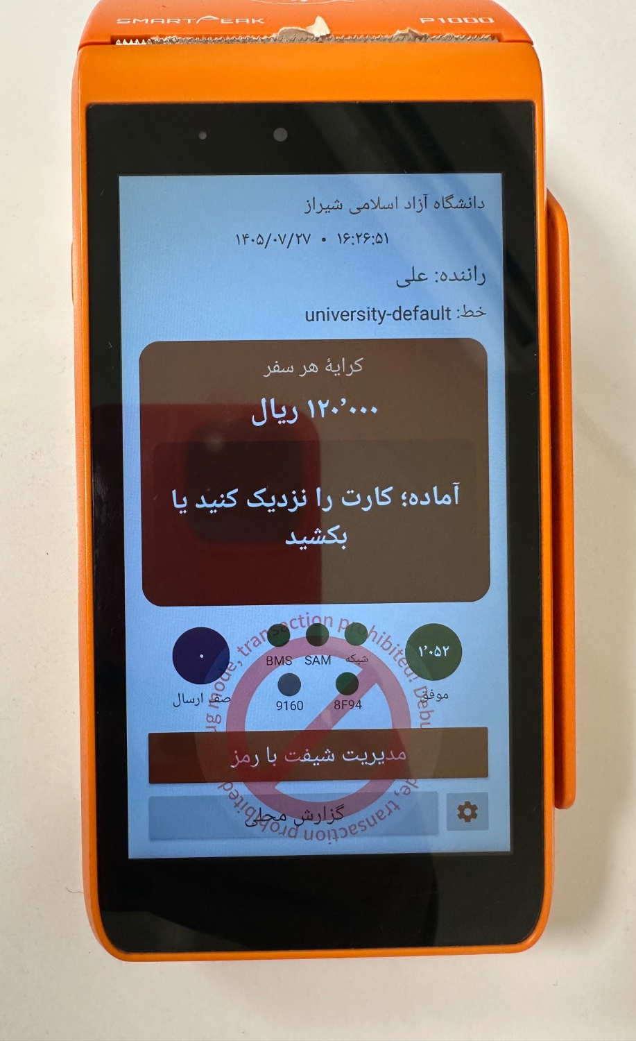 |  | 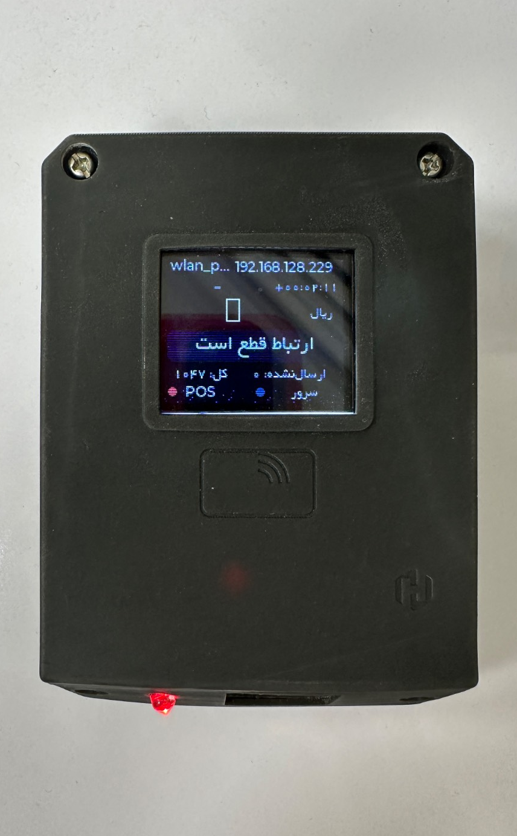 | 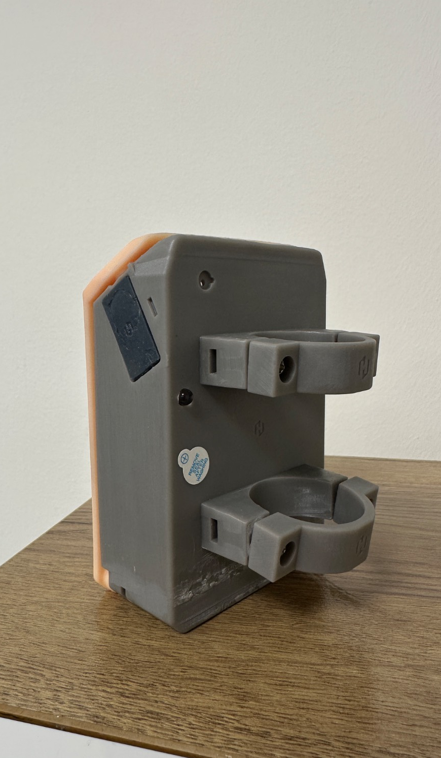
 | Smart parking

The Pars Hadish smart parking management system manages vehicle entry and exit, calculates parking charges, and tracks payments through a central panel.
The system uses license plate recognition cameras to record vehicle movements and calculates parking duration and charges based on defined tariffs. Managers and operators can also review available capacity, parked vehicles, bills, and payment statuses.
For example, the vehicle's license plate and entry time are recorded on arrival. When calculating the charge, the system reviews the vehicle's movement records and issues the corresponding bill. The driver pays through the connected payment methods, and the operator can track the bill and payment status. If the license plate has been read incorrectly, staff can review the image and correct the information. The scope of this profile is parking capacity monitoring. Features such as reservations, tariff calculation, payment, and barrier control are defined and evaluated separately according to each project's needs.


Product features and capabilities
- Automatic vehicle movement recording: Recognize license plates and record entry and exit times without cards or tags.
- Capacity monitoring: Display available and occupied capacity by parking zone.
- Tariff definition: Set parking charges based on time, day, and parking location.
- Billing and payment management: Calculate charges and connect to a payment terminal, kiosk, or gateway.
- Vehicle search: View movement history, images, and records associated with each license plate.
- Information correction: Correct license plate recognition errors and merge records relating to the same parking stay.
- Vehicle list management: Define vehicles eligible for free access and flag the arrival of blacklisted license plates.
- Equipment management: View equipment connection statuses and live camera feeds.
- Management reporting: Review vehicle movements, usage, bills, payments, and equipment statuses.
- SMS and notifications: Send billing and payment information and display system alerts.
- User management: Define roles and access levels for managers and staff.

Users and applications

Usage steps
- Parking facility setup: Register zones, capacity, equipment, and tariffs.
- Vehicle entry recording: Recognize the license plate and record the entry time and location.
- Parking and capacity monitoring: View parked vehicles and remaining capacity.
- Charge calculation and billing: Determine the amount based on parking duration and the applicable tariff.
- Payment and exit recording: Track payment and complete the vehicle movement record according to the parking facility's rules.
- Report review: Review vehicle movement information, bills, payments, and equipment performance.

Images:
Image of the consolidated parking report: | Parked vehicle status report:
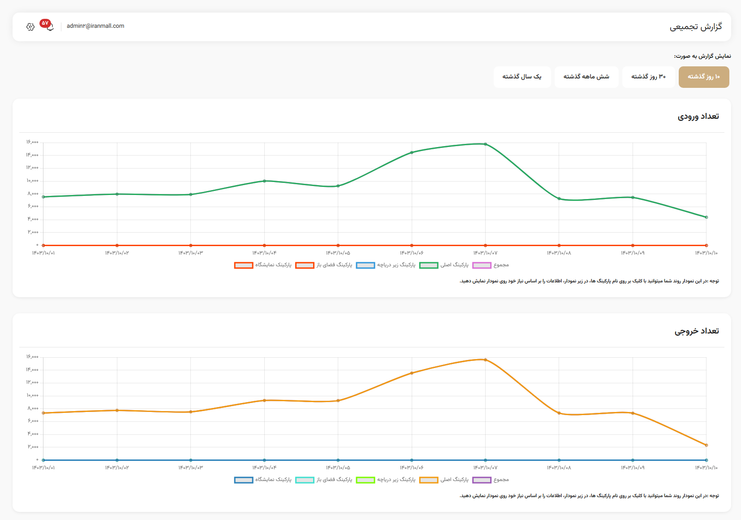 | 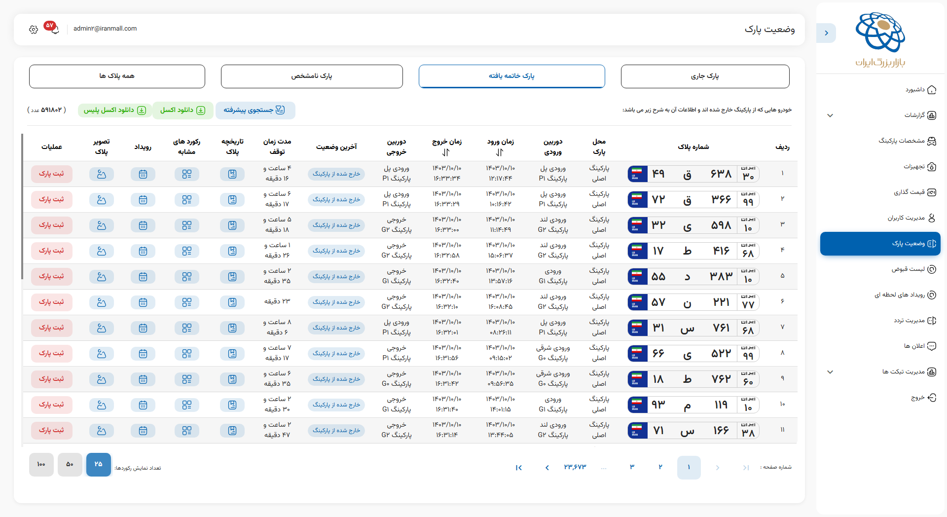
Live parking report: | Daily parking report:
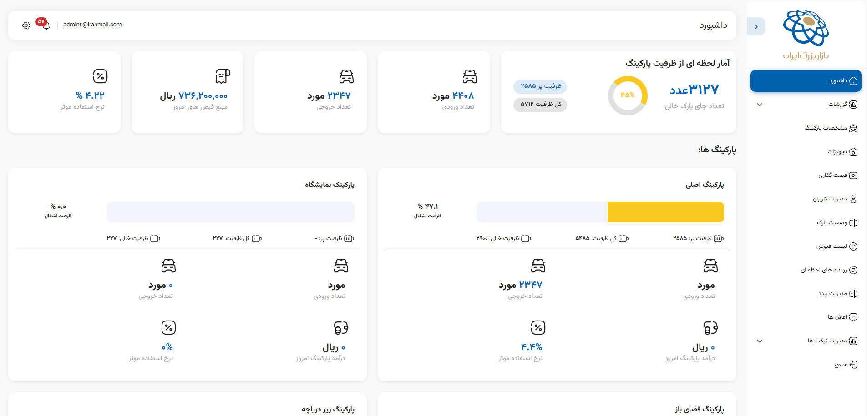 | 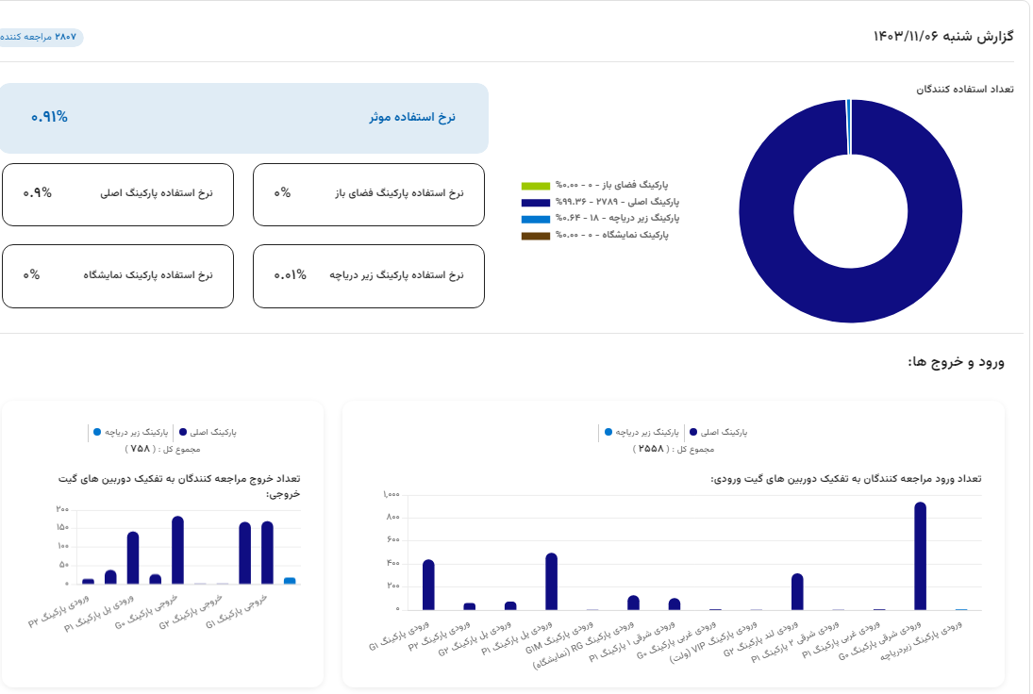
Parking payment system: | Notifications:
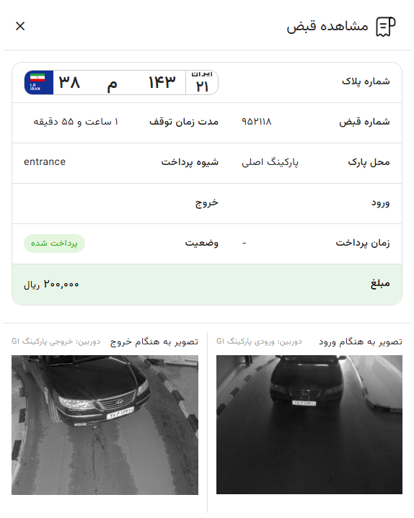 | 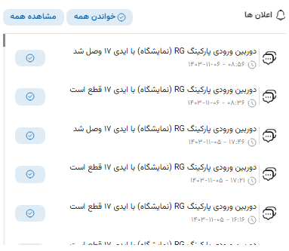

Mobile monitoring and observation recording concept

The Pars Hadish mobile monitoring and observation recording system provides a centralized solution for recording violations and field observations, collecting evidence, and managing follow-up.
The system allows inspectors and monitoring patrols to identify municipal violations on site and record them with an image, location, and violation type. The recorded information is sent to the management center so that staff can review cases, refer them to the responsible units, and track their progress.
For example, when an inspector observes a municipal violation, they can record its image and location and submit a report. After reviewing the evidence, a staff member at the center refers the case to the operational unit for action. Managers can also review case statuses, recurring violation locations, and monitoring patrol performance.
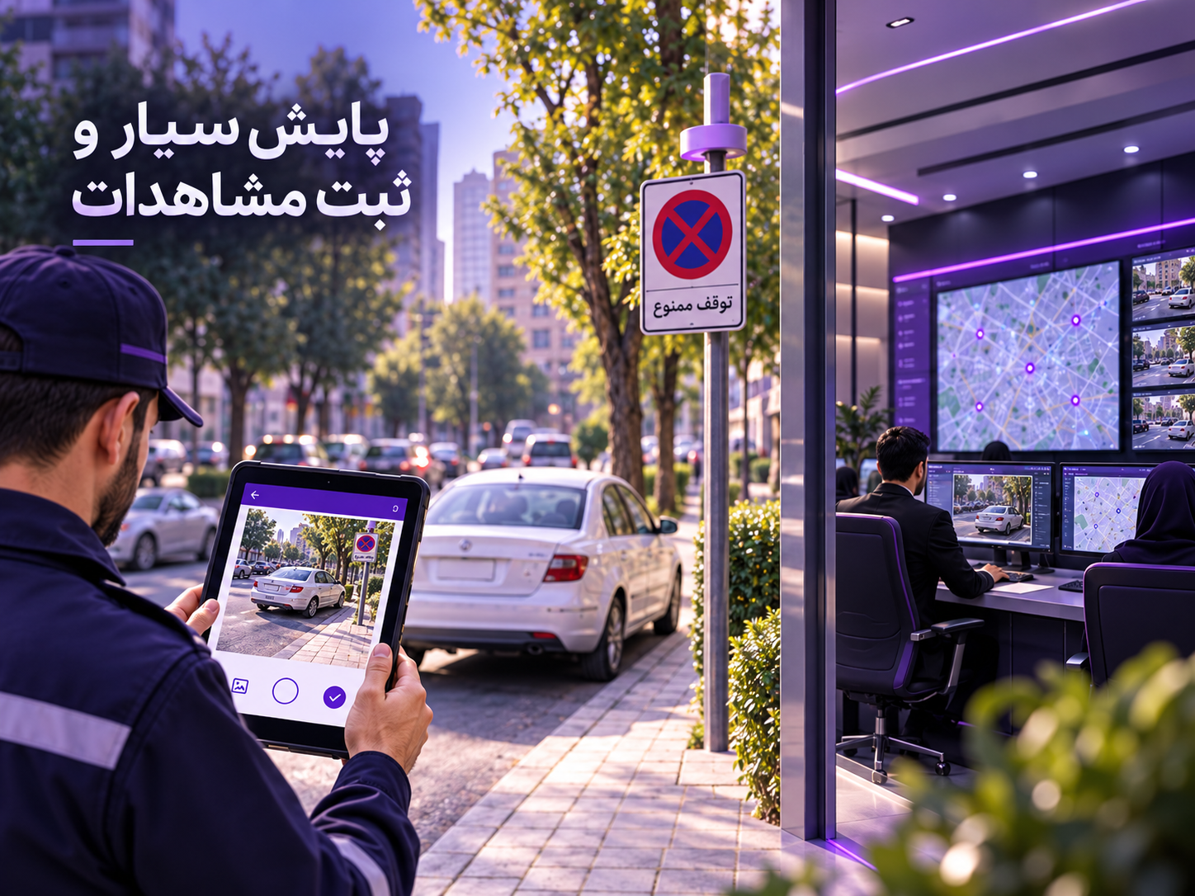

Product features and capabilities
- Field observation recording: Allow inspectors to record municipal violations and incidents.
- Image evidence recording: Record images associated with each observation or violation.
- Geolocation: Record the geographical location of a violation.
- Violation classification: Specify the violation type when submitting a report.
- Case management: Maintain the information and evidence associated with each violation.
- Case referral: Send recorded violations to the units responsible for handling them.
- Follow-up tracking: View case statuses and actions taken.
- Monitoring patrol management: Review field inspectors' activities and performance.
- Management reporting: Display violation statistics, recurring locations, and patrol performance.

Users and applications

Hadish Ticket

Hadish Ticket is an integrated electronic ticket sales and management system for cultural, historical, sports, leisure, and tourism venues. It is designed to organize ticket sales, issuance, validation, and monitoring, helping venues manage in-person, online, operator-assisted, and kiosk sales through a centralized platform.
Managers can define projects, locations, services, ticket types, time slots, capacity, and prices in the system, and monitor ticket sales and usage in real time. Hadish Ticket also supports transaction recording and tracking, cancellation rules, user management, and management and financial reporting.
For example, a ticket office operator or the online sales system selects the service and number of tickets. Once payment is complete, an electronic ticket is issued with a QR code, barcode, or ticket number. At entry, control staff can check the ticket's validity, associated service, usage, and remaining entitlement. Recording the sales source and usage history also makes it easier to track tickets and control repeat use of a service. The system can be used for individual venues and large networks of multiple venues.
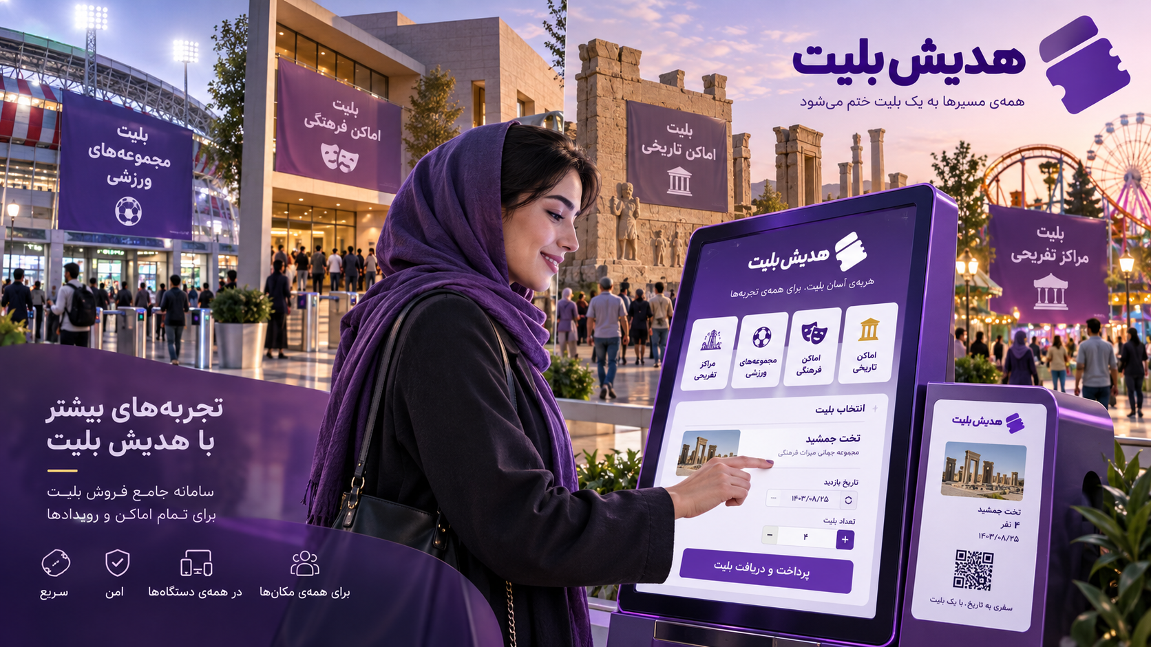

Product features and capabilities
- Multichannel sales: Support online, in-person, operator-assisted, and kiosk sales.
- Project and location definition: Manage multiple projects, venues, and attractions in one system.
- Service and ticket management: Define service types and different types of tickets.
- Time slot and capacity management: Control capacity separately for each service and time slot.
- Pricing and discounts: Set prices, discounts, and sales conditions for each ticket.
- Electronic ticket issuance: Generate tickets with QR codes, barcodes, or ticket numbers.
- Ticket validation: Check ticket validity at entry and record usage.
- Cancellation and record keeping: Apply cancellation rules and maintain complete operational records.
- Transaction and payment management: Record payments and connect to payment gateways.
- Sales source recording: Retain the sales source for more accurate tracking and settlement.
- User and access management: Define roles and access levels appropriate to each responsibility.
- Management reporting: Provide reports on sales, usage, transaction details, and performance.

Users and applications

Usage steps
- System structure setup: Register projects, locations, services, ticket types, time slots, and capacity.
- Sales configuration: Define prices, discounts, sales rules, and ticket sales channels.
- Purchase request: Have the operator or user select the service and number of tickets.
- Payment and ticket issuance: Record the transaction and generate an electronic ticket for the selected service.
- Entry and usage control: Validate the ticket and record usage at the entry point.
- Monitoring and reporting: Review sales, capacity, usage, transactions, and project performance.

Images:
Tourism card management in the panel | Group policy configuration
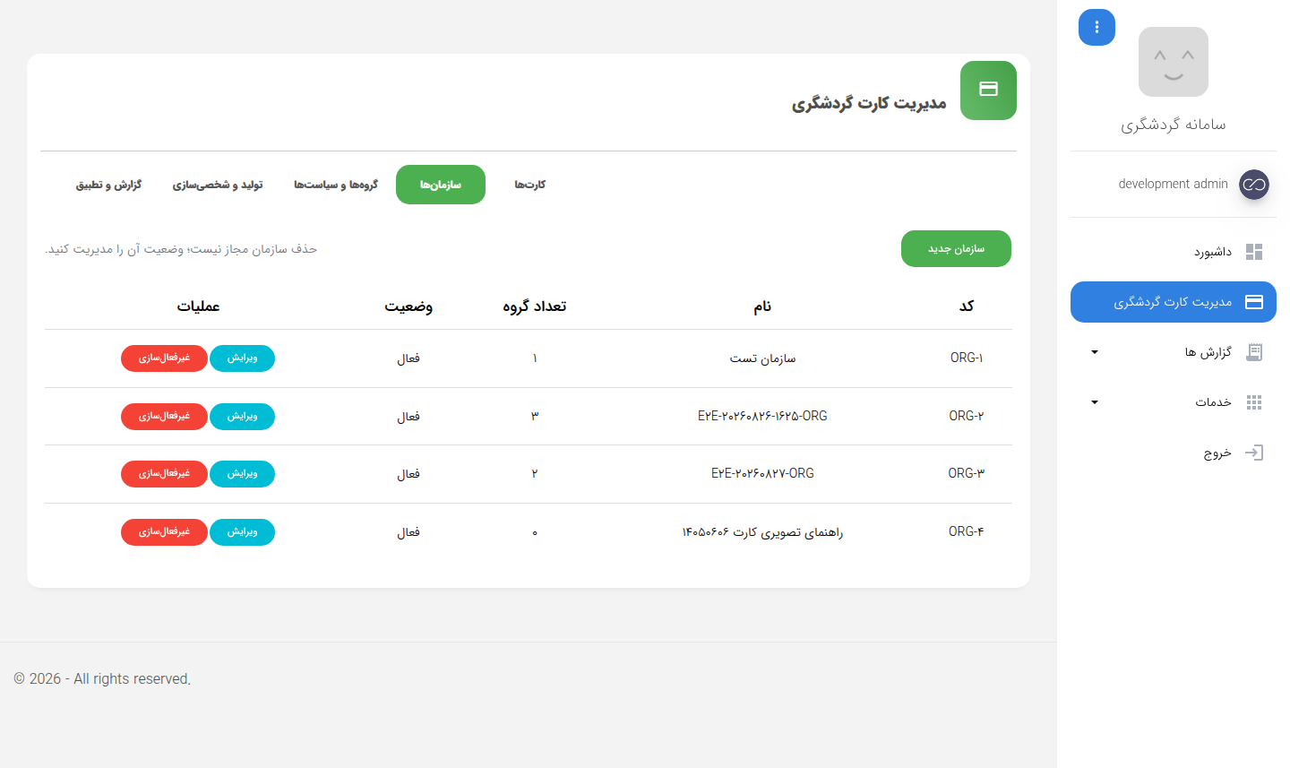 | 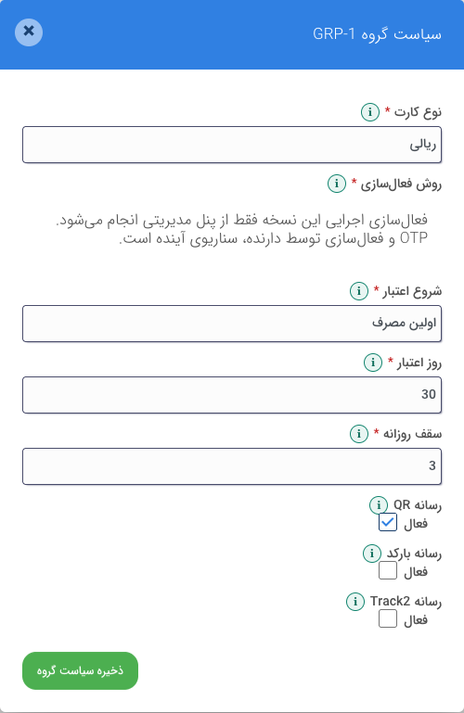
Service selection from the project structure:
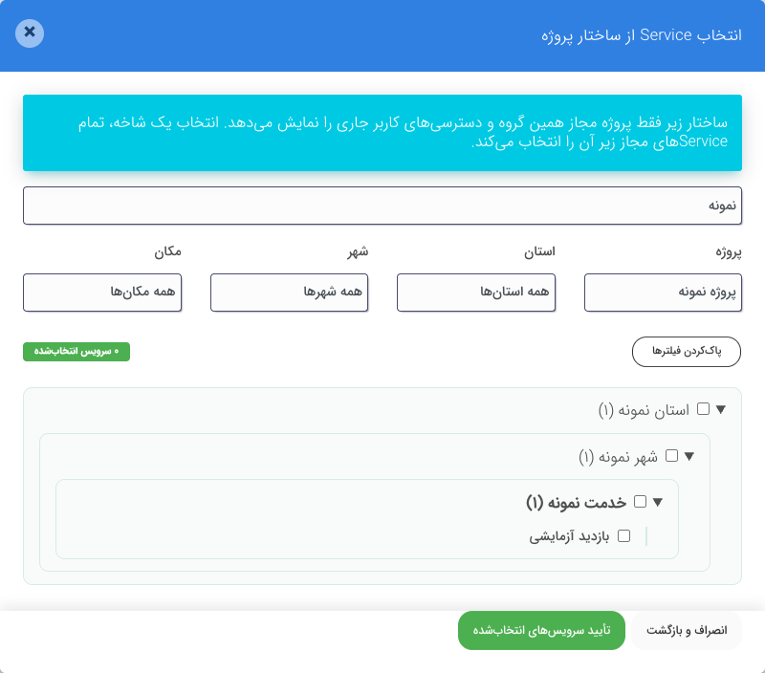

Hadish Market

Hadish Market is Pars Hadish's integrated e-commerce and sales management platform, designed for launching online stores, managing in-person sales, and creating marketplaces with multiple vendors. The system manages products, orders, inventory, payments, and sales processes through a centralized platform.
In the online store, customers can search for products by category, brand, price, and other attributes, review product details and availability, and place orders. Vendors and managers can also use dedicated panels to manage products, pricing, discounts, orders, and sales performance.
For example, a customer selects several products from different vendors and adds them to one shopping cart. After the delivery address and time have been specified, the final order total is calculated, including discounts and shipping charges. The customer pays and can track the order until delivery. On the store side, orders are made available to vendors for processing and preparation. Hadish Market is also designed to integrate online and in-person sales and connect to retail checkout, inventory management, and accounting systems.
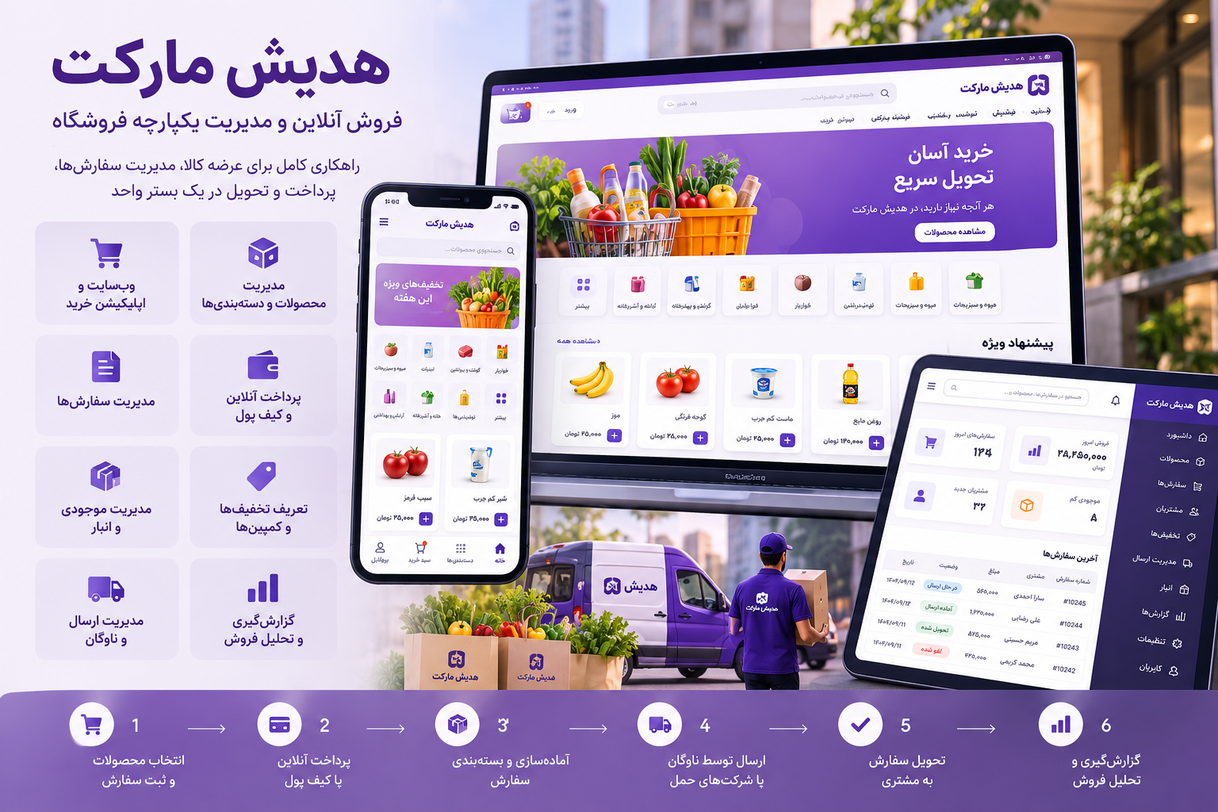

Product features and capabilities
- Online store: Offer and sell products through a website and application.
- Marketplace with multiple vendors: Manage products and orders from different vendors on one platform.
- Product management: Record products, images, specifications, brands, categories, and prices.
- Advanced search and filtering: Find products by name, brand, price, and attributes.
- Unified shopping cart: Purchase from multiple vendors in one cart.
- Inventory and warehouse management: Control stock and connect to warehouse management systems.
- Order management: Record, process, cancel, and track orders.
- Delivery management: Record addresses, specify delivery times, and track shipments.
- Electronic payment: Support bank payment gateways, wallets, and various payment methods.
- Discounts and customer loyalty: Manage coupons, gift cards, and loyalty programs.
- Dedicated vendor panel: Manage products, prices, orders, and sales reports.
- In-person sales management: Connect retail checkout and POS devices to the sales process.
- User management: Define roles and access levels for managers, vendors, and operators.
- Intelligent marketing: Analyze customer behavior and run targeted campaigns.
- Intelligent product recommendations: Display similar and complementary products based on purchasing behavior.
- Management reporting: Review sales, transactions, inventory, and vendor performance.
- Integration with other systems: Connect to accounting, warehouse management, and enterprise software through APIs.

Users and applications

Images:
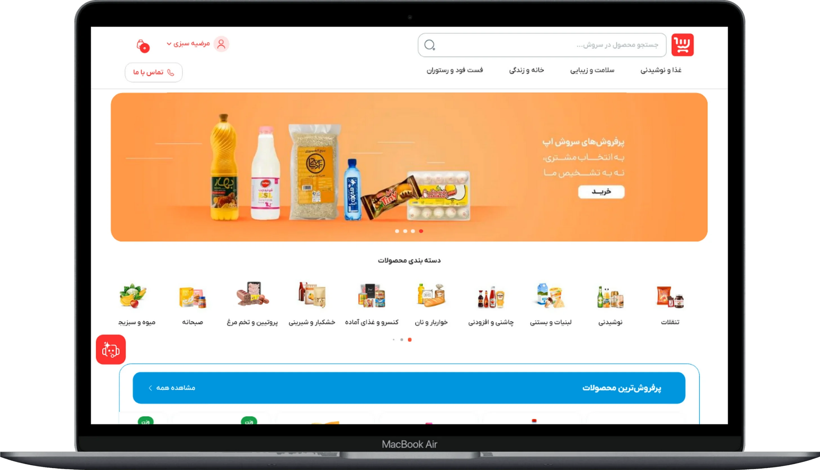 | 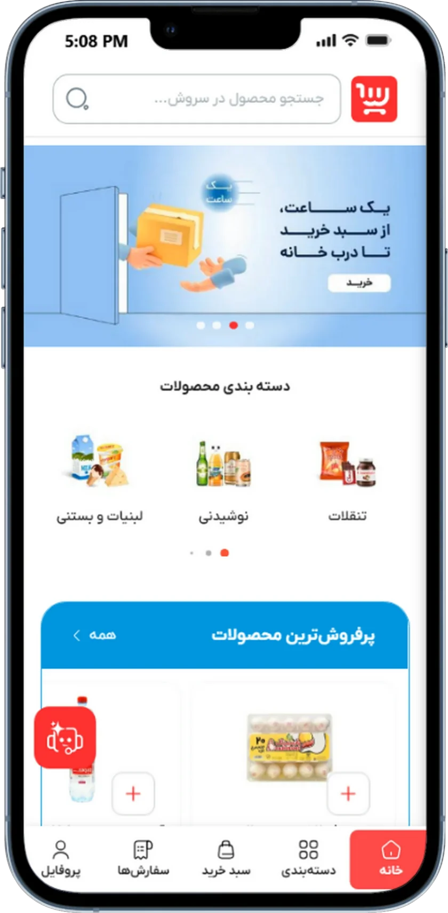
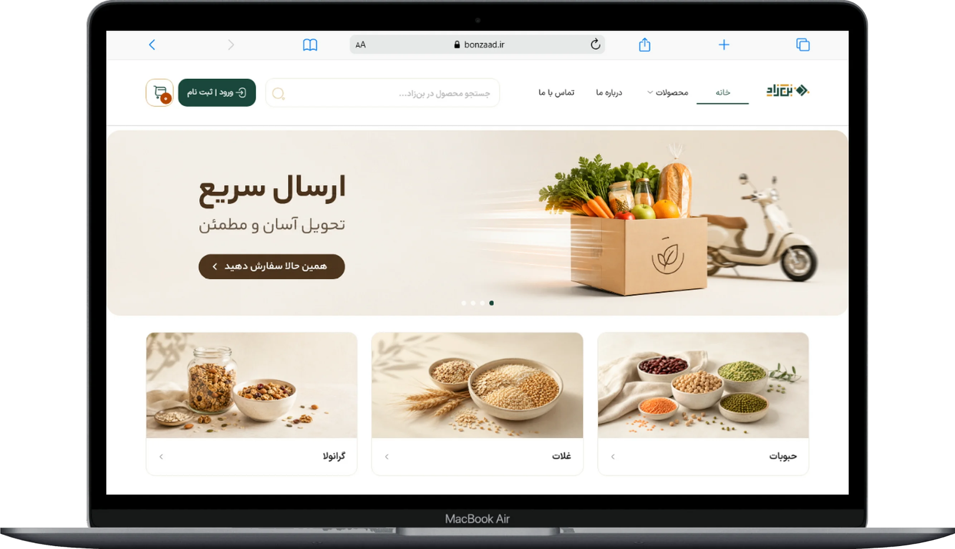 | 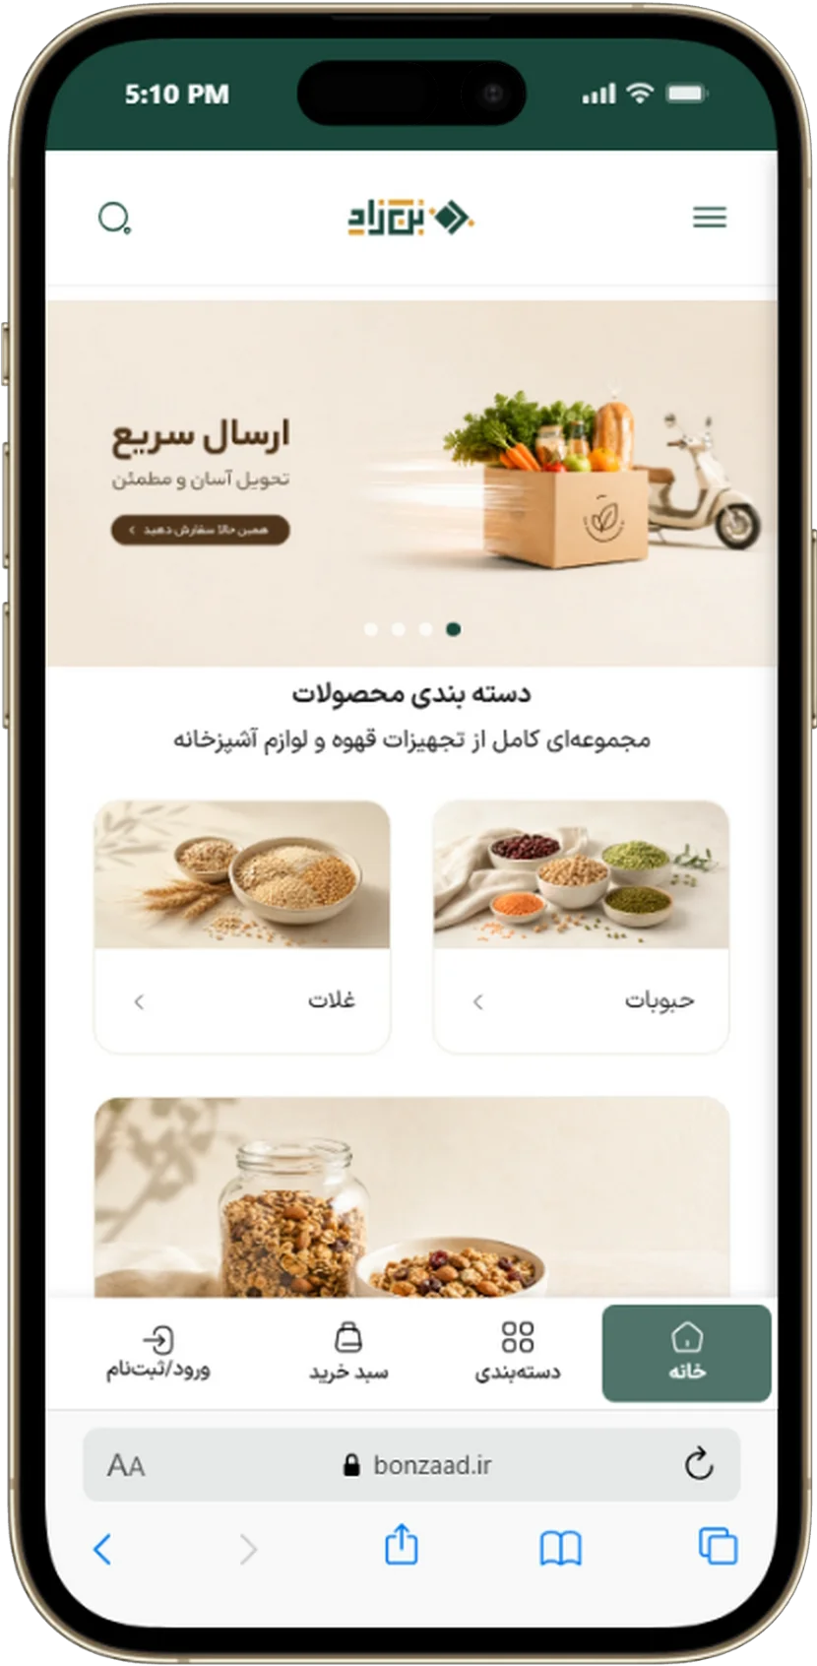

Product page:
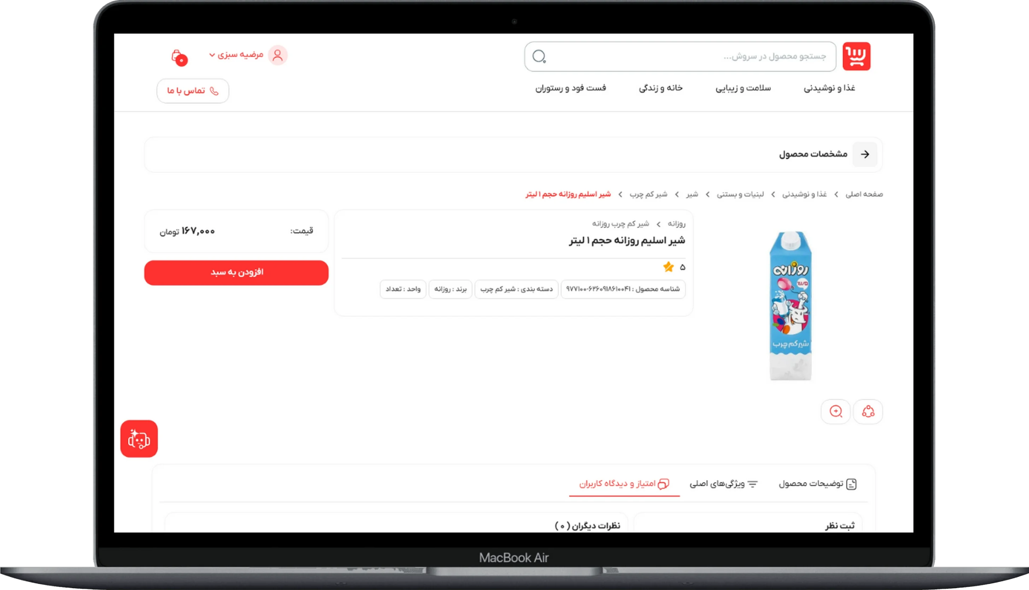
Shopping cart:
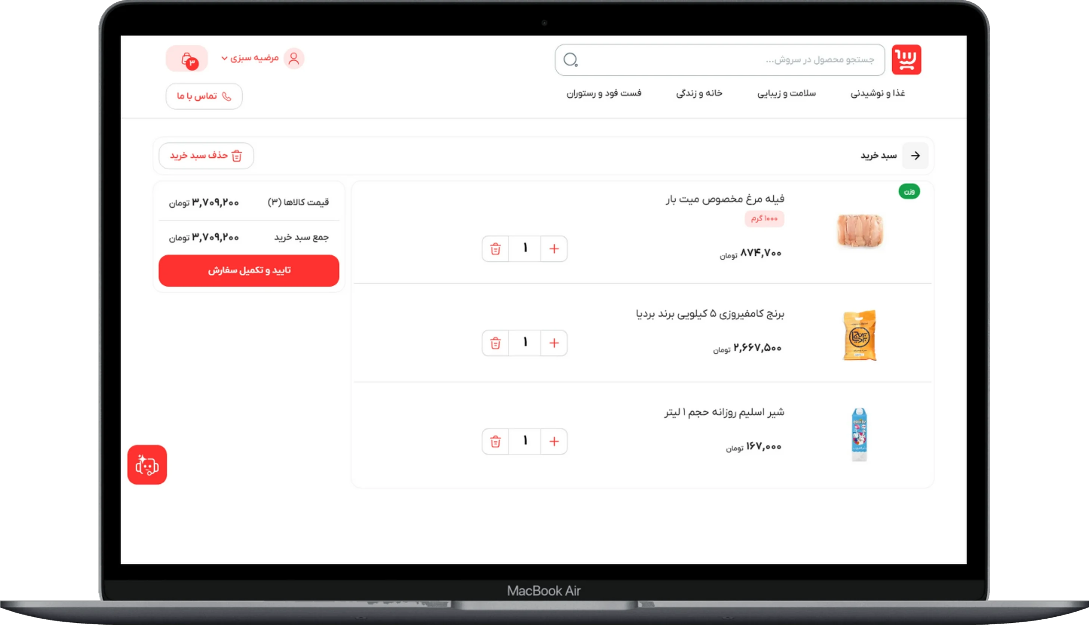
Management reports:
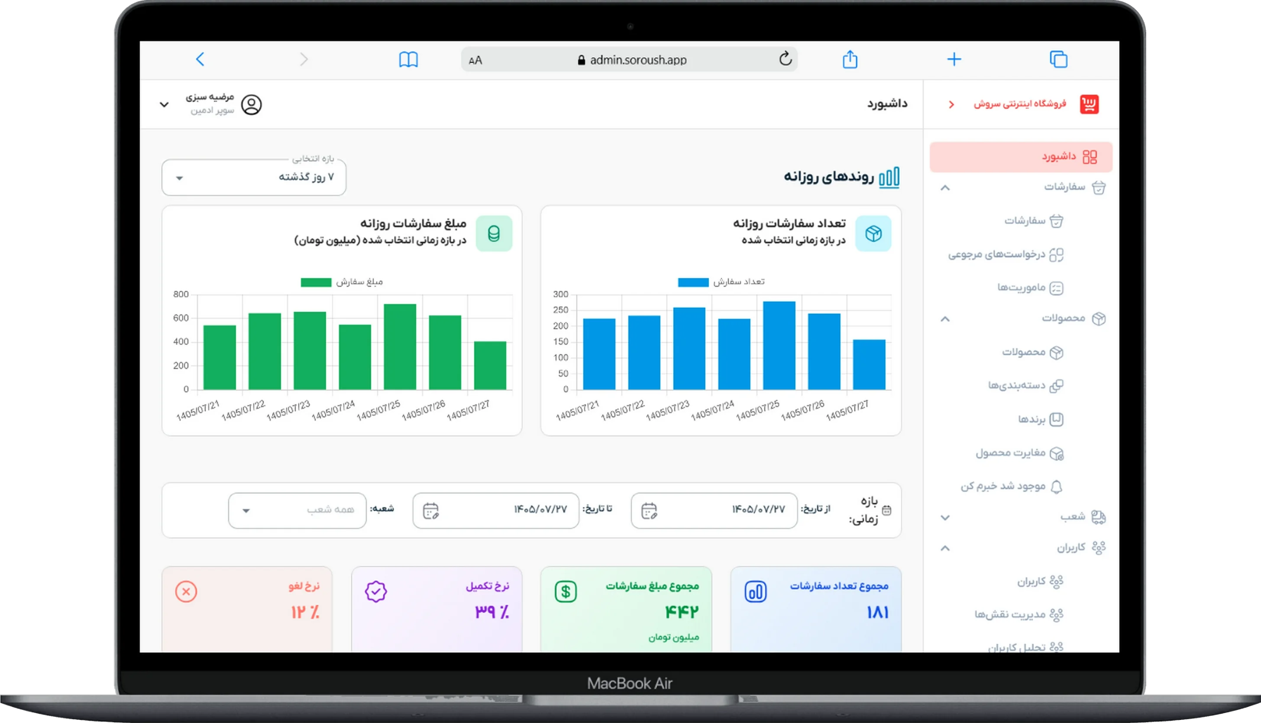

Order processing:
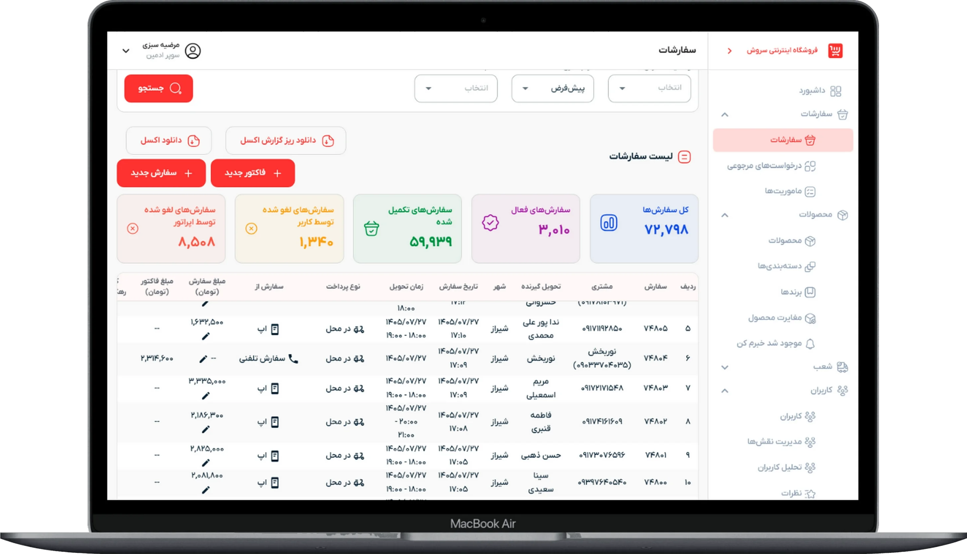

Customer support chatbot and intelligent assistant

The Hadish intelligent customer support assistant is Pars Hadish's intelligent response and customer relationship management system. It uses artificial intelligence to automate user support and manage conversations, requests, and support services in one place.
The system connects to the organization's knowledge base and dedicated services to answer users' questions, review their activity and request history, and provide guidance suited to the service. When an automated response is insufficient, the conversation is transferred to a human support agent so that the request can be handled without restarting the conversation.
For example, when a user asks about a ticket or transaction status, the intelligent assistant retrieves information from the relevant service and provides an appropriate response. If further review is needed, the user is connected to an operator, who follows up on the request with access to the conversation history. Managers can also use the management panel to review conversation volumes, response quality, request statuses, and staff performance.
The system can be used by service organizations, online stores, tourism centers, and organizations offering a range of services.
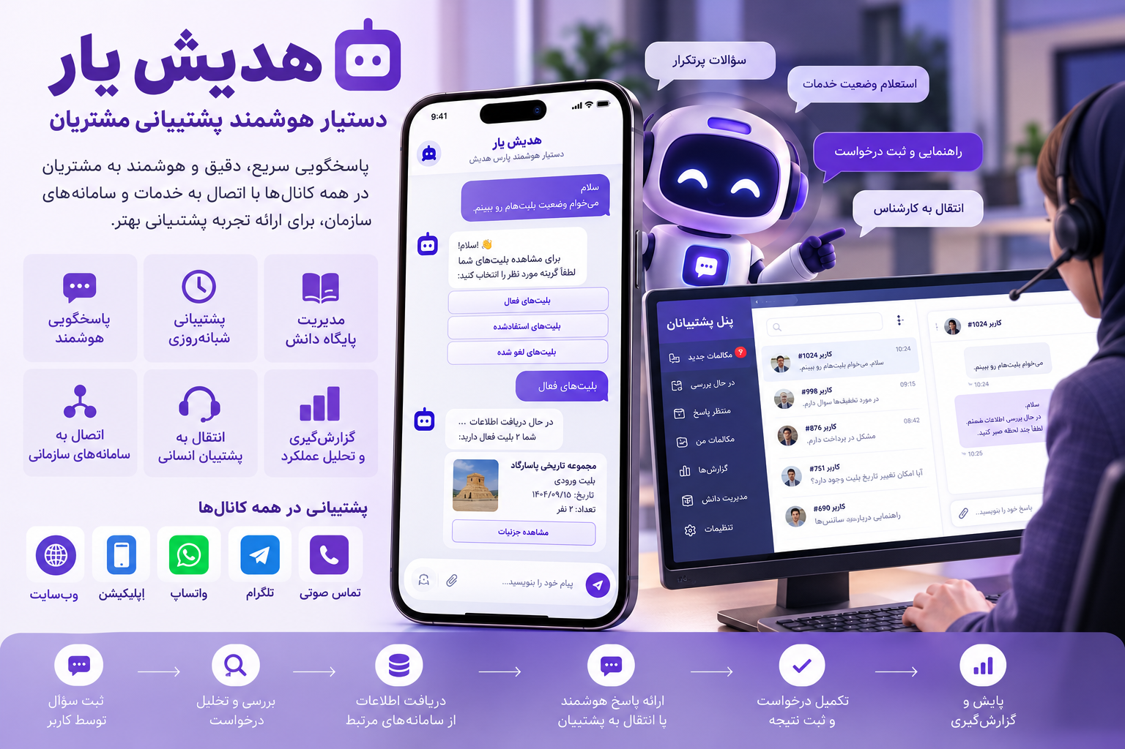

Product features and capabilities
- Intelligent responses: Answer users' questions using artificial intelligence.
- Round-the-clock support: Provide automated responses outside working hours as well as during them.
- Knowledge base management: Define and update information specific to each service.
- Service classification: Separate topics and tailor responses to each service.
- Enterprise service connections: Retrieve user information and activity history through APIs.
- Frequently asked questions: Display predefined questions and provide quick answers.
- Related question suggestions: Display follow-up questions to continue the conversation.
- Conversation history management: Store and display conversations and their statuses.
- Activity history: Show information and statuses for services used by the user.
- Human support connection: Transfer requests requiring review to an operator.
- Support conversation management: Accept, assign, track, and close conversations.
- File and image sharing: Exchange documents and voice messages with support staff.
- Ratings and surveys: Collect feedback on responses from the bot and support staff.
- User and access management: Define managers, support specialists, and access levels.
- Management dashboard: View the status of conversations and support requests.
- Analytical reporting: Review waiting times, service quality, and support staff performance.

Users and applications

Images:
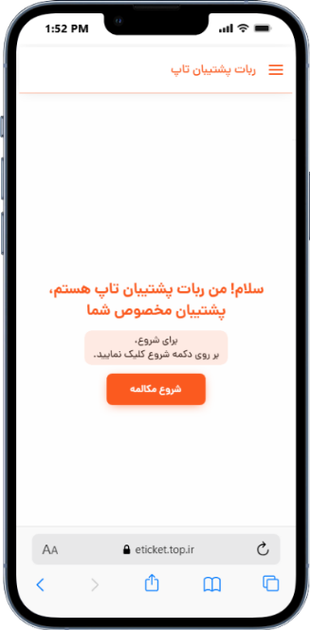 | 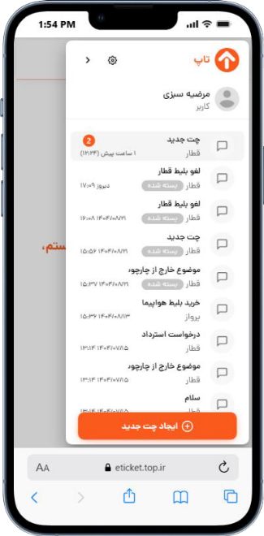 | 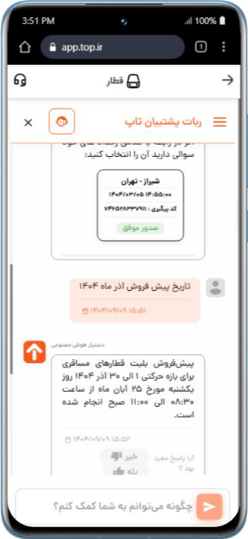 | 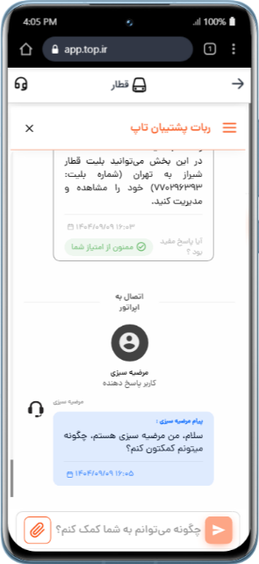

Intelligent polyclinic appointment and queue management system

The Pars Hadish intelligent polyclinic appointment and queue management system manages appointments, organizes waiting queues, and coordinates patient reception and service delivery in healthcare facilities.
The system gives reception staff, physicians, and service staff a unified view of appointment schedules, patient attendance, waiting queues, and services in progress, allowing them to manage each stage of a visit. Each stage, including check-in, joining the queue, being called, and completion of service, is recorded separately so that the patient's status can be tracked throughout the process.
For example, when a patient arrives at the polyclinic for an appointment, reception staff record their attendance in the system and add them to the waiting queue. The physician or staff member responsible for the service room calls the next patient and records completion of service once the visit is over. Clinic managers can also review the daily schedule, appointment statuses, waiting patients, and services in progress.
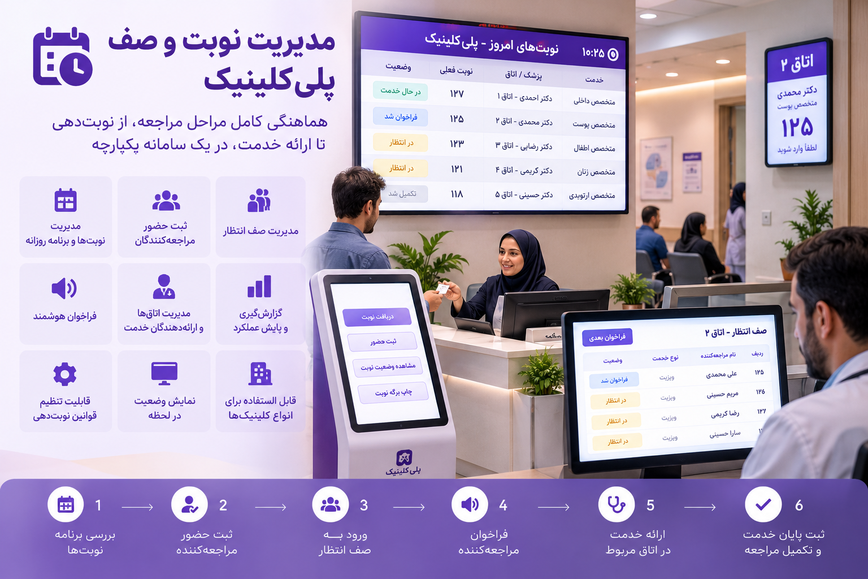

Product features and capabilities
- Appointment management: View the daily schedule and patients' appointment times.
- Patient check-in: Record patients' arrival and attendance at the clinic.
- Waiting queue management: Add patients to the queue and track their waiting status.
- Patient calling: Allow the physician or service staff member to call the next patient.
- Appointment status management: Display the different stages of each patient's visit.
- Service monitoring: View the status of services currently in progress at the clinic.
- Service completion recording: Record completion of the operational stage of a patient's visit.
- Daily schedule display: View appointments, the waiting queue, and service statuses in one place.
- Visit tracking: Review the patient's status from reception through completion of service.

Users and applications

Images:
Main clinic application view with patients and appointments | Reception requests:
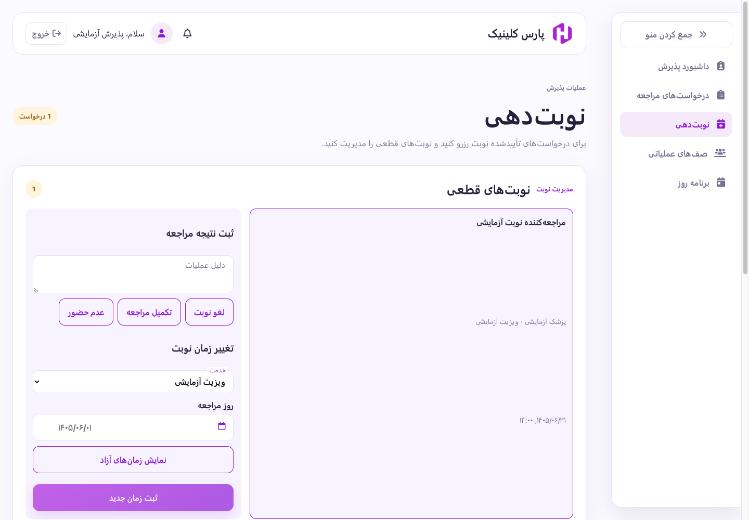 | 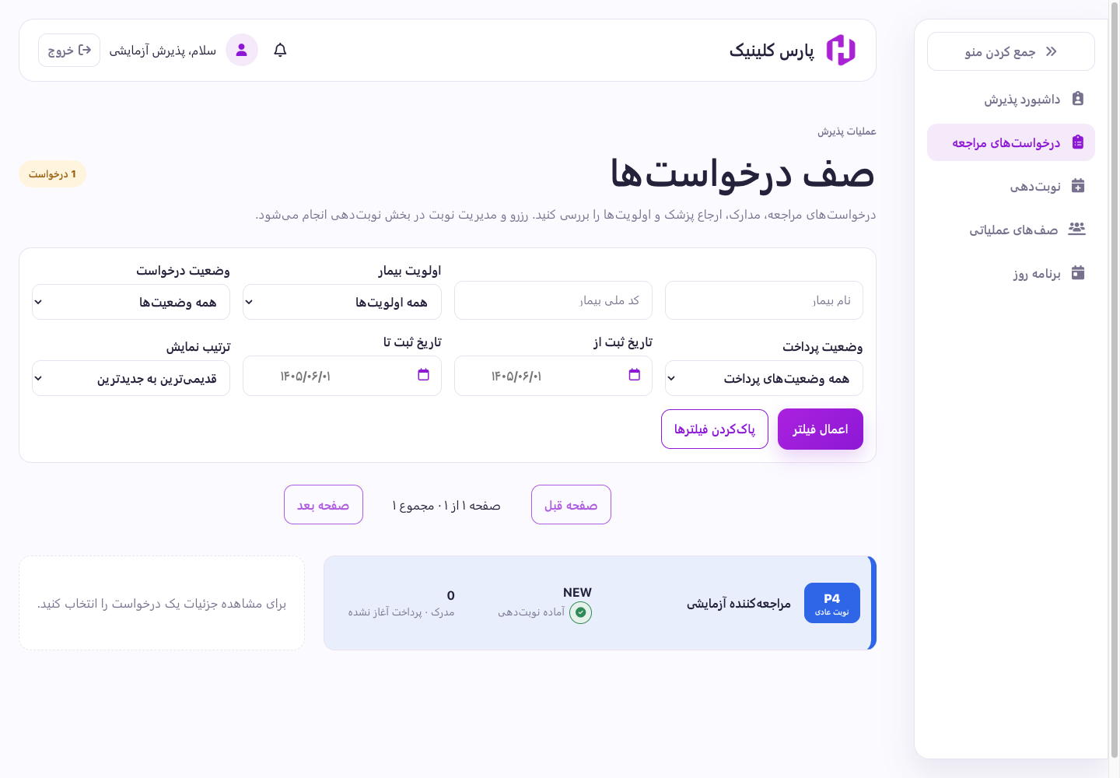

Clinic queue and patient calling system
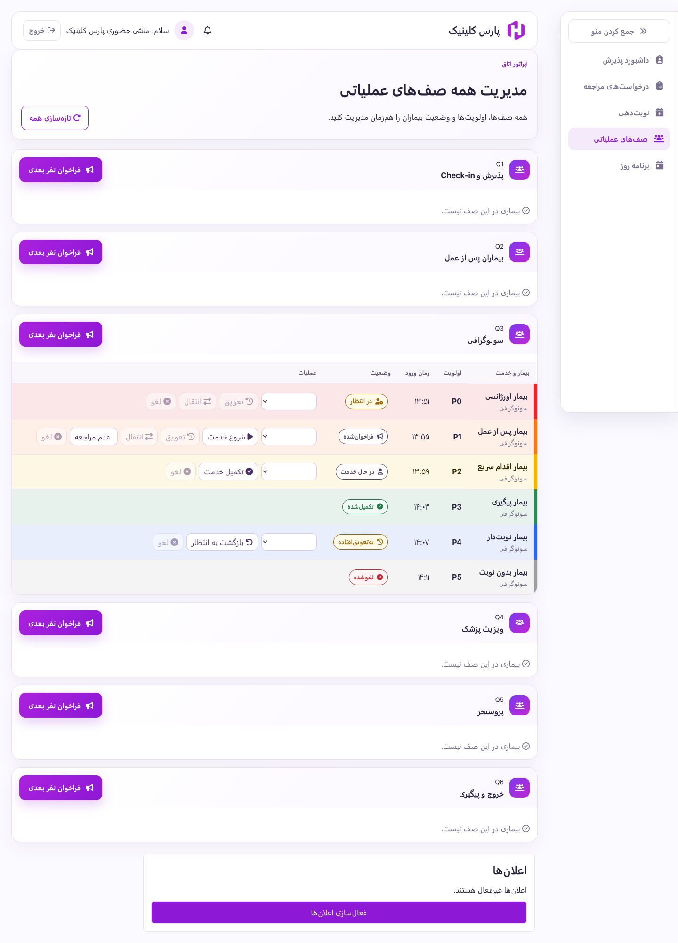

Intelligent physician and clinic assistant

Hadish Teb is Pars Hadish's intelligent medical information management and clinical decision support system. It uses artificial intelligence to help physicians review patient records, analyze medical information, and identify differential diagnoses.
Before the patient's consultation, the system reviews the medical record, treatment history, laboratory results, and diagnostic documents. Using scientific sources and authoritative medical references configured in the system, it presents possible differential diagnoses and supporting information to the physician. The physician can review the analysis and converse directly with the intelligent assistant about findings, diagnostic hypotheses, and any additional information needed.
In addition to maintaining medical records centrally, the system can connect to hospital information systems (HIS) and other healthcare systems. It can be used as a physician's assistant in medical practices, clinics, polyclinics, and healthcare centers.
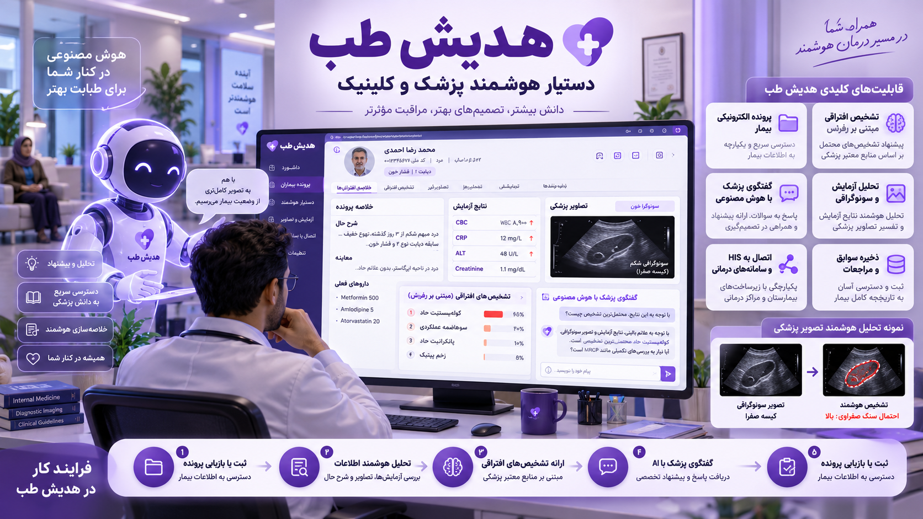

Product features and capabilities
- Electronic patient records: Record and maintain medical histories and treatment information.
- Intelligent record review: Analyze patient information and history before the physician's consultation.
- Differential diagnoses: Suggest diagnostic possibilities based on the record and specified scientific sources.
- Analysis based on authoritative sources: Restrict AI analysis to the configured medical references.
- Intelligent conversation with the physician: Support questions and answers about findings and proposed diagnoses.
- Medical record summaries: Summarize the patient's history, results, and important information.
- Intelligent medical image processing: Analyze laboratory images, ultrasound images, and other image-based documents.
- Laboratory result analysis: Extract and review laboratory information alongside the patient's history.
- Visit history management: Maintain a history of consultations and information associated with each visit.
- Medical document management: Record and maintain laboratory results, images, and diagnostic documents.
- HIS connectivity: Exchange information with hospital information systems.
- Healthcare system integration: Connect to other medical software and infrastructure.
- Clinical decision support: Provide analytical information to assist the physician's assessment.

Users and applications

Images:
This assistant has three sections:
- Physician panel
- Physician assistant panel for staff such as secretaries and receptionists
- Administrator panel
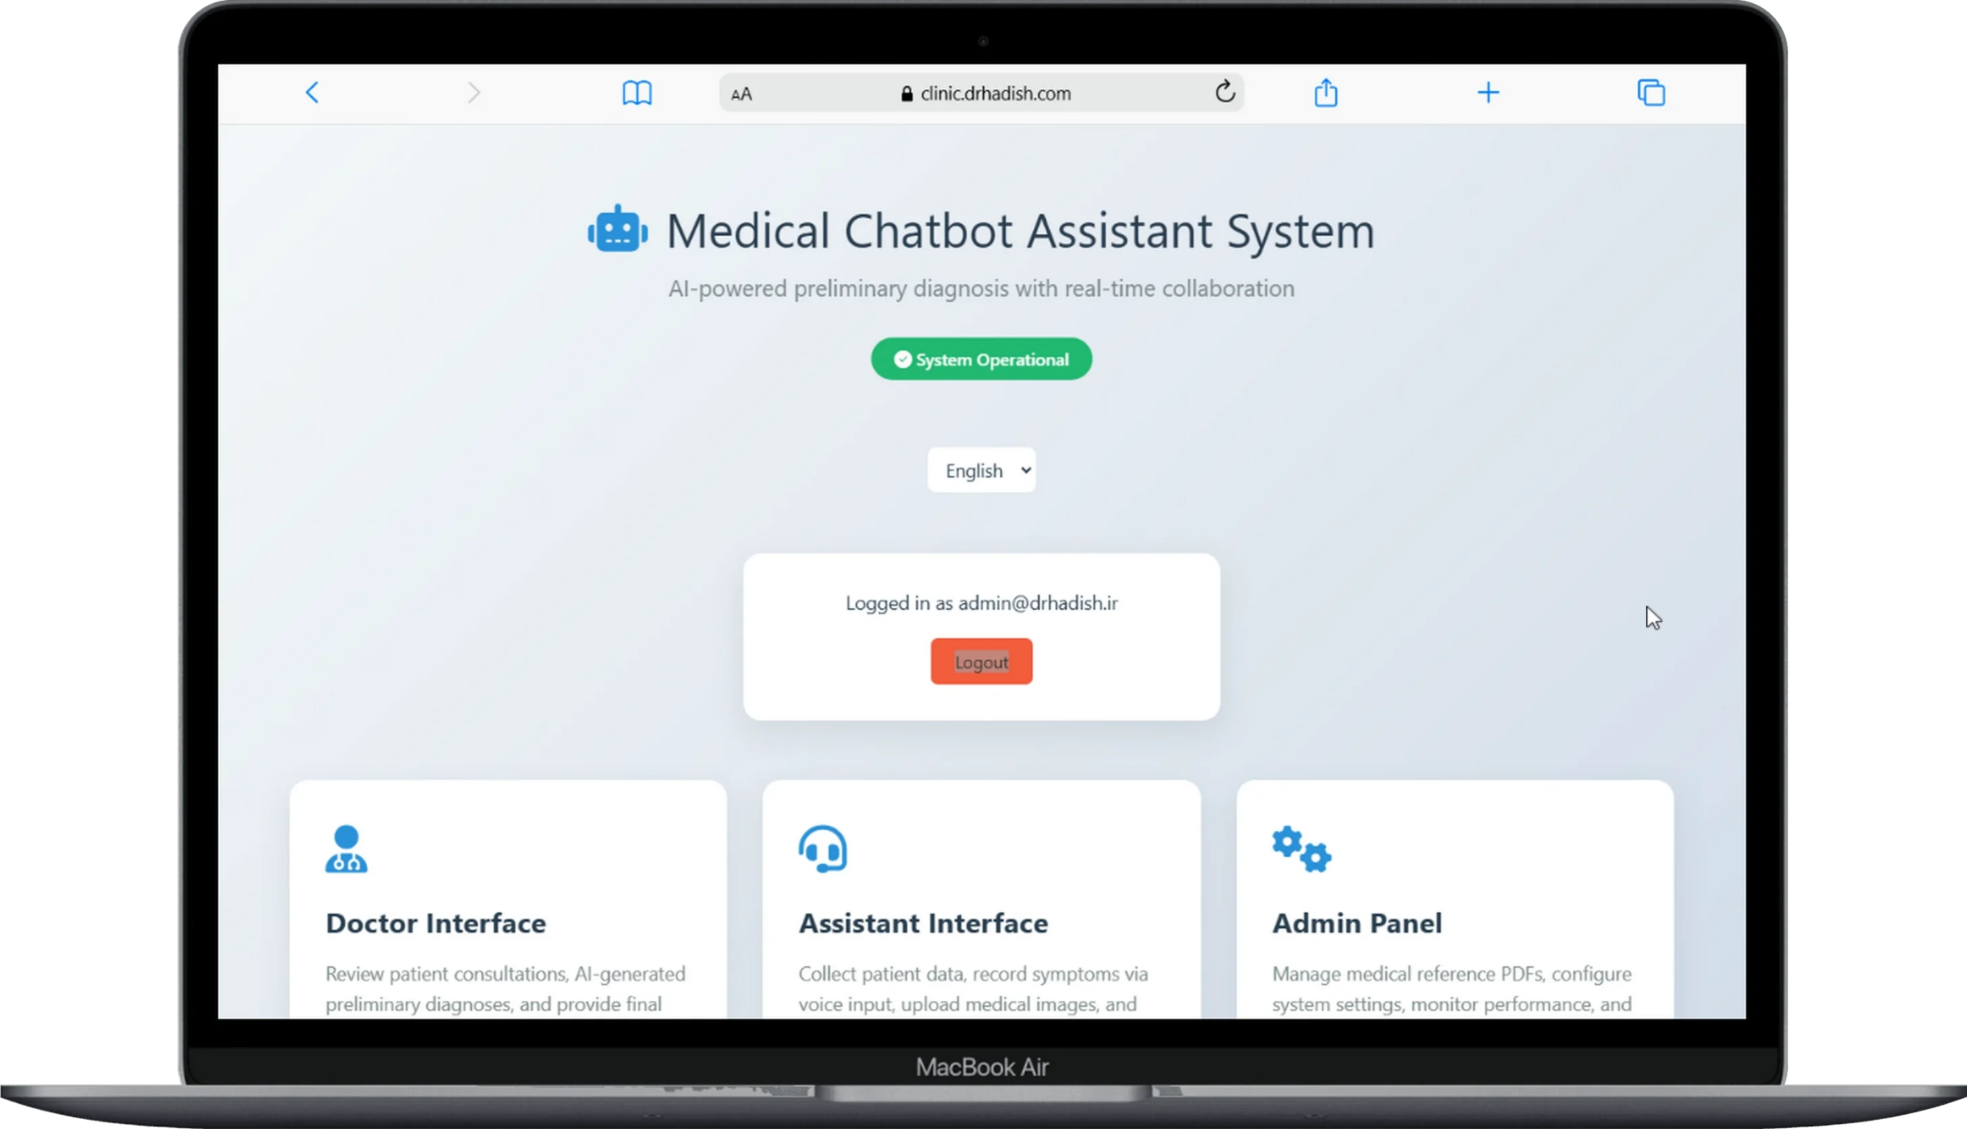
Patients awaiting consultation in the physician panel:
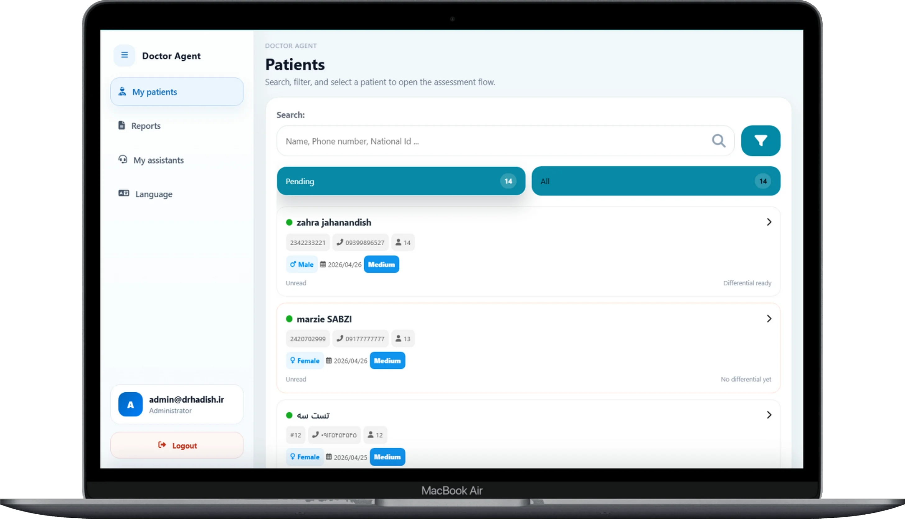
Patient record:
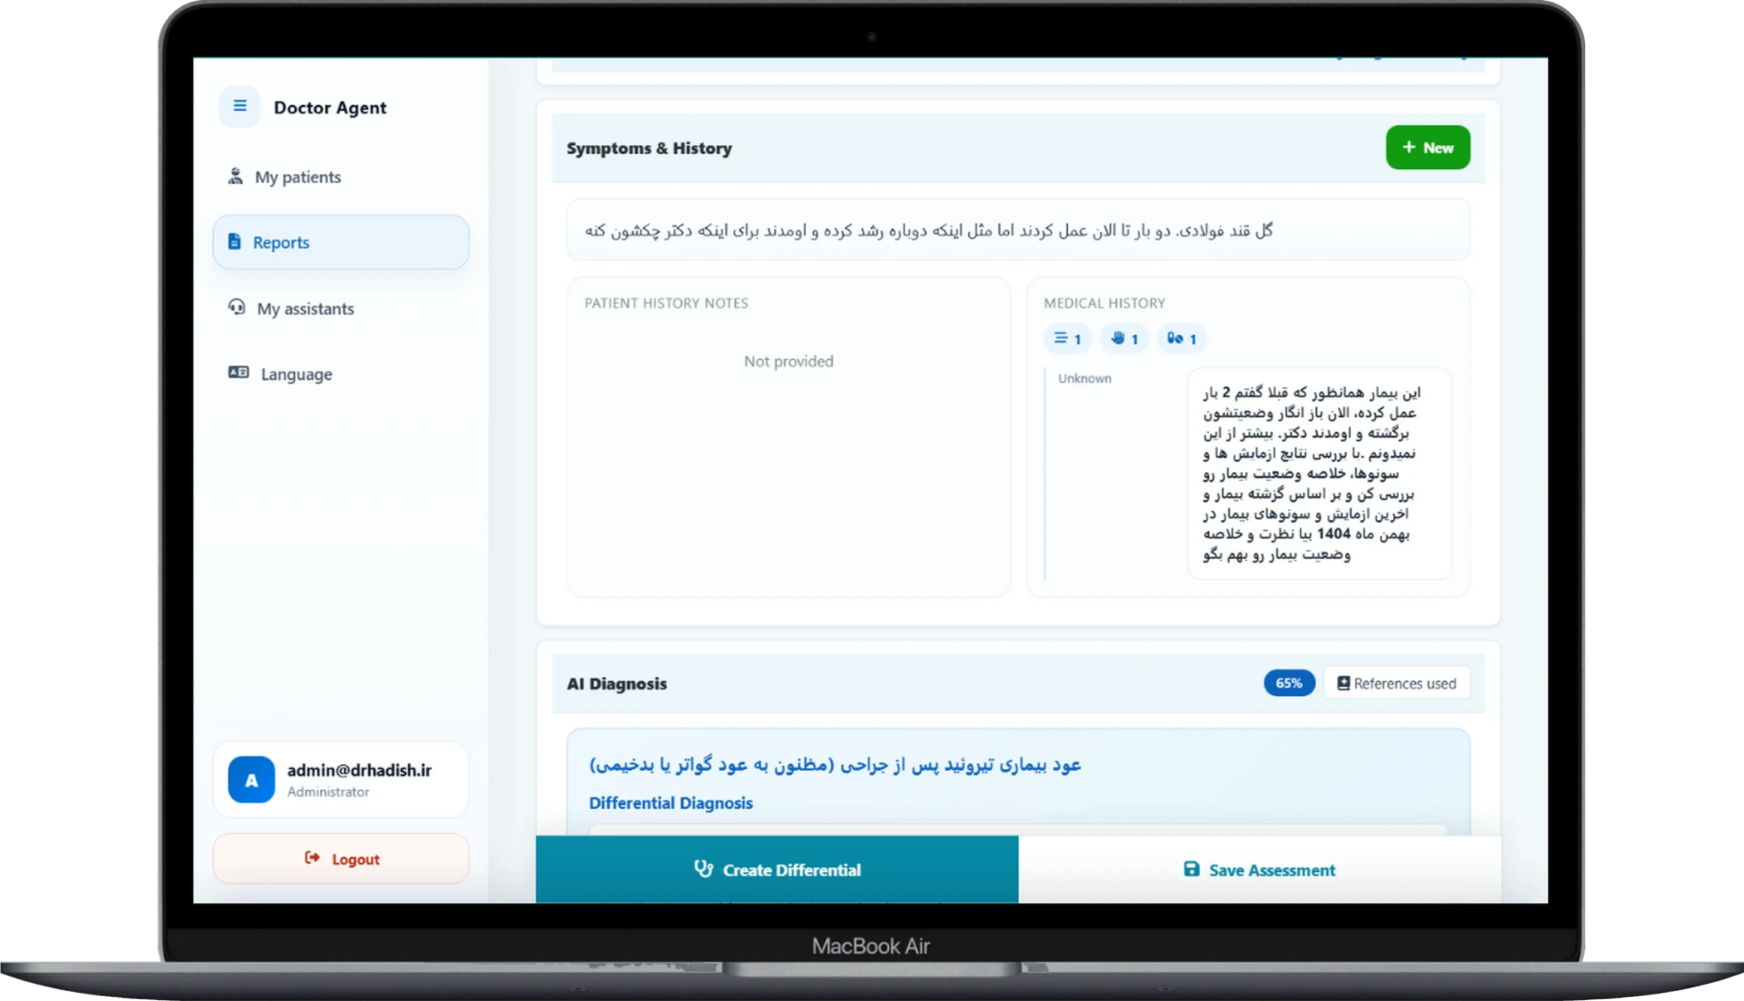
AI diagnoses:
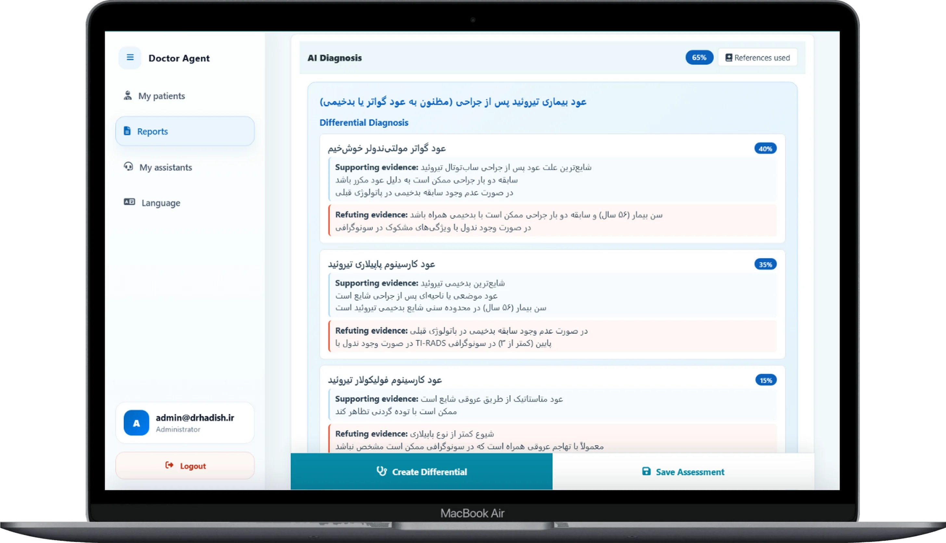
Ultrasound images, laboratory results, and documents with their analyses:
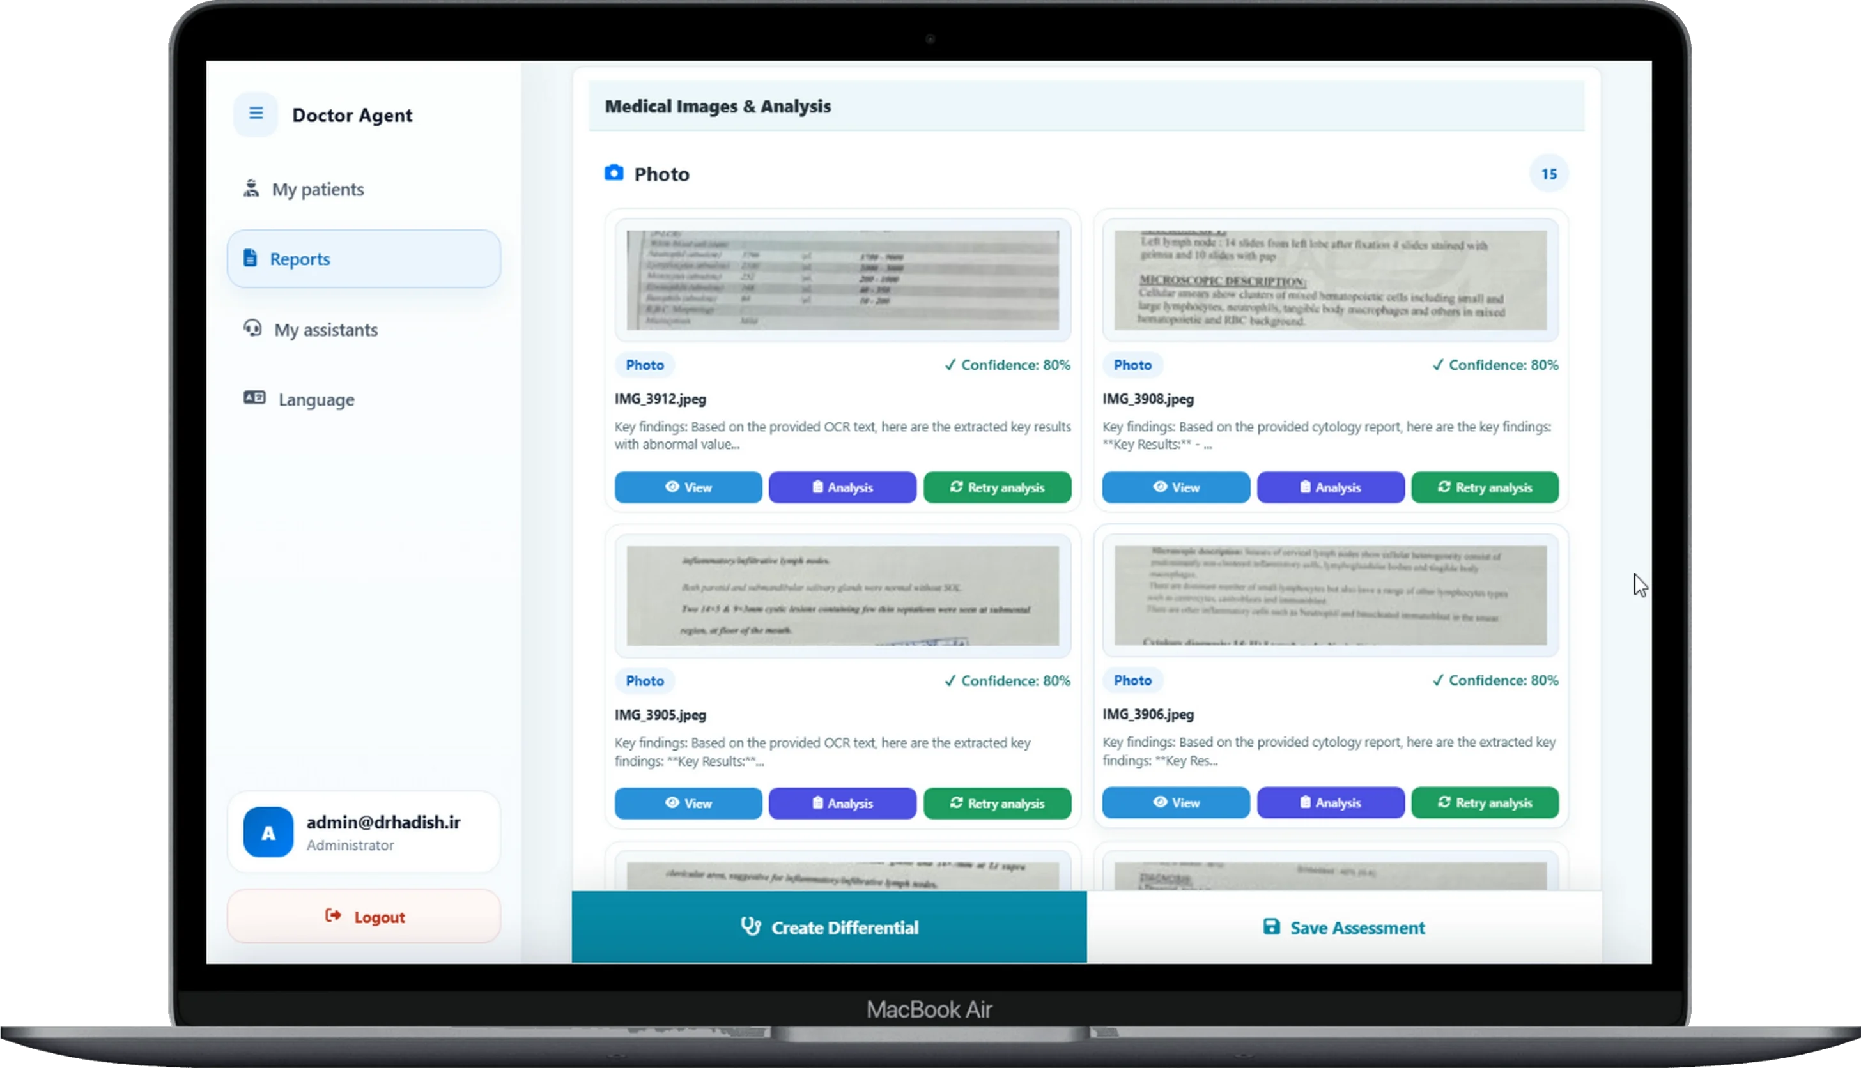

Contact information
Chief Executive Officer: Amir Sodagaran
Telephone: +98 917 716 0542
Email: info@pars-hadish.com
Website: pars-hadish.com

